**Title:** Aspen's influence on fire radiative energy and burn severity is moderated by forest composition, structure, and fire weather in the Southern Rockies

**Target journal:** [Ecology Letters](https://onlinelibrary-wiley-com.colorado.idm.oclc.org/page/journal/14610248/homepage/forauthors.html#tips1)

**Code:** <https://github.com/maxwellCcook/aspen-fire/tree/main/Aim2>

# Abstract

# 

# Highlights

* A novel application of satellite-derived fire radiative power (FRP) as a proxy for fire intensity is described.
* We present the application of a rich database of active fire detections, burn severity, and wall-to-wall forest composition and structure to elucidate the relationship between primary forest types and their structure on fire intensity and severity during recent fires in the Southern Rockies, with an emphasis on quaking aspen.
* Predominant forest types in the Southern Rockies influence satellite-derived fire radiative power (FRP) and composite burn index (CBI) differently, *relative to quaking aspen*.
* Spatial hierarchical models provide insights into the spatial dependence and pattern of Fire radiative Power (FRP) and Composite Burn Index (CBI) across the Southern Rockies. FRP exhibits tight spatial clustering (spatial range ~1.2 km) whereas CBI spatial effects are at larger scales (spatial range ~7.8 km), suggesting more broad-scale landscape spatial patterns. Lodgepole dominated forests exhibit the greatest effect on increased FRP relative to aspen.
* Forest composition and structure can more tightly predict CBI than FRP as evidenced by tighter credible intervals in the model results.
* Forest structure metrics (live basal area, tree density, height, and mean quadratic diameter) exert different effects on FRP and CBI across predominant forest types.
* Quaking aspen may have significant moderating effects on fire behavior across forest types, but especially in lodgepole-predominant forests, although the effects are mediated by Vapor Pressure Deficit (VPD).

# 

# Introduction

Forest composition, or the abundance, dominance and diversity of forest species, has an important influence on fire activity and post-fire ecosystem impacts (Hagmann et al., 2021). Alongside climate and topography, forest composition and species traits help govern fire regimes and fire effects at a variety of spatial and temporal scales (Johnstone et al., 2016). Tree species composition and structure (*e.g.*, density, height, diameter), for example, help drive *fire intensity*, or how hot a fire burns, and *fire severity*, or the consumption of organic matter (Keeley, 2009). Fire intensity and severity influence suppression difficulty (Thompson et al., 2018), impacts to the built environment (Penman et al., 2014), and ecosystem responses such as post-fire tree recruitment (Chapman et al., 2020; Meigs & Krawchuk, 2018). Given recent extreme fire activity and changes to the composition, structure and fire regimes of western North American forests (Hagmann et al., 2021; Hessburg et al., 2021), there is an urgent need to understand the influence of forest species composition and structure on contemporary fire intensity and severity.

The modification of forest composition and structure is a viable management tool often leveraged to reduce wildfire hazard to communities and ecosystems (Prichard et al., 2021). These management actions often involve reduction of fuels through mechanical treatment or prescribed fire, thereby reducing the potential for extreme fire activity (Agee & Skinner, 2005; Stephens et al., 2009). However, this presents a persistent management problem where treatments must be revisited to maintain positive benefits. Furthermore, while far more prescribed fire is ultimately needed to restore increasingly fire-starved ecosystems in the western U.S. (Parks et al., 2025), its use is limited by policy restrictions, public support, and a shortening window of appropriate weather conditions for burning (Schultz et al., 2019; Swain et al., 2023). The promotion of “fire-resistant” species, which may provide natural buffers to extreme fire behavior that are more self-sustaining, presents a complimentary management tool to reduce extreme fire behavior (Girardin & Terrier, 2015). With increasing fire activity and hazards, particularly across the western U.S. (Parks & Abatzoglou, 2020), assessments of which species may provide these benefits and under what conditions they are likely to do so are needed.

In some regions of western North America, quaking aspen (*Populus tremuloides Michx.*) is one forest species potentially capable of reducing extreme fire hazard (Fechner & Barrows, 1976). Aspen, which is also the most widely distributed tree species in North America and often considered a keystone species (Rogers et al., 2020), has been characterized by potentially fire-moderating traits such as lower canopy bulk density, higher canopy base height, and greater leaf moisture content (DeByle & Winokur, 1985; W. Shepperd, 1990; Shinneman et al., 2013). Existing in a functional gradient of seral (*e.g.*, having a conifer component) to stable (*e.g.*, pure stands), aspen exhibits varying fire regimes and degrees of fire resistance (Rogers et al., 2014; Shinneman et al., 2013). Generally, seral aspen exhibits more extreme fire behavior compared to stable aspen and, in turn, fire activity drives the persistence of either functional type (Morris et al., 2019; Shinneman et al., 2013). Evidence points to fire weather and stand condition influencing the fire behavior in aspen, where even pure stands are likely to burn when the conditions align (DeRose & Leffler, 2014). However, with these potentially fire-moderating traits, aspen may offer a natural buffer, a so-called *living fire break*, to extreme fire intensity and severity. Despite this recognition, there remains a knowledge gap between management and scientific understanding of how, when, and where aspen moderates fire, especially relative to other forest types and during recent extreme fire activity at regional-to-continental scales (Nesbit et al., 2023).

Widespread availability of satellite remote sensing data before, during, and after wildfires presents a unique opportunity to quantify the influence of aspen on wildfire activity across large spatial scales. Burn severity mapping, which is based on differences between pre- and post-fire multispectral imagery, is one of the most commonly applied uses of satellite remote sensing in fire ecology (Szpakowski & Jensen, 2019). Satellite-based metrics of burn severity, such as the composite burn index (CBI), have been shown to correlate well with field-based measurements, enabling large-scale assessments of ecosystem impacts and their drivers (Parks et al., 2019a). In tandem, active fire detection, which relies on middle-infrared (~ 4 µm) imagery, has become a crucial tool for monitoring global fire activity (Wooster et al., 2021). Spectral radiance in the middle-infrared is used to calculate fire radiative power (FRP), which is a measure of the energy released by actively burning fires and is highly correlated with the rate of biomass consumption per unit time (Kaufman et al., 1998; Schroeder et al., 2010; Wooster et al., 2003). Studies have applied FRP to, for example, track wildfire smoke emissions (Li et al., 2019, 2020) and investigate the relationship between energy released and fire size (Laurent et al., 2019). However, as a proxy for fire intensity, FRP has been underutilized to assess the influence of forest composition and structure, fire weather, and landscape factors on fire activity. The harmonization of satellite-derived burn severity metrics such as CBI and fire intensity proxies like FRP alongside forest inventories is a promising approach to exploring these relationships.

To investigate the influence of aspen and other forest types on fire intensity and severity during recent (2017-2023) wildfires, we harmonized satellite-based FRP and CBI with imputed wall-to-wall forest inventory data derived from the United States Forest Service (USFS) Forest Inventory and Analysis (FIA) program. Using Bayesian spatial hierarchical modeling, we investigate three primary questions: (i) how do dominant forest types influence FRP and CBI *relative to aspen*; (ii) how does forest composition (e.g., co-occurring species) and species-specific structure, such as live basal area, tree height and diameter, influence FRP and CBI; and (iii) where aspen co-occurs with other forest types, how does its dominance, measured as the proportion of live basal area, influence FRP and CBI both with and without mediating effects of fire weather. To account for landscape and climatic effects, we include variables describing topography (elevation, slope, and topographic position) and fire weather including vapor pressure deficit (VPD) and energy release component (ERC), which relate to atmospheric and fuel aridity and have been shown to correlate with fire activity (Abatzoglou & Williams, 2016). Additionally, and given the spatial-temporal dependence of wildfires, we include random effects for the day-of-burn and a complex spatial model, uncovering the landscape spatial patterns of FRP and CBI. The results of this study have important implications for management of aspen and other common forest types in the context of fire intensity and burn severity in the Southern Rockies. We also highlight a novel application of satellite-derived FRP as a proxy for fire intensity to investigate the biotic and abiotic controls and spatial patterns of radiative energy released. These methods can be applied across large geographic regions and to answer a variety of important questions related to forest and fire management.

# Methods

## 2.1. Study Region and Wildfire Census

The Southern Rockies includes portions of southern Wyoming, central and western Colorado, and northern New Mexico. Aspen is the dominant deciduous forest species in the region, encompassing an estimated 9,482 km2 (7.4% of total land area) based on recent high-resolution mapping (Cook et al., 2024). In this region, aspen co-occurs with nearly every major forest type including ponderosa mixed-conifer, lodgepole, and Engelmann spruce and subalpine fir (hereafter spruce-fir), and across a wide range of elevation and site conditions (Bartos, 2001). We collected a census of recent (2017-2023) managed wildfire events across the Southern Rockies from the ICS-209-PLUS (St. Denis et al., 2023; updated through 2023). Since 2017, 113 wildfires have burned approximately 1.68M acres (X% of forested area) including five large events (>100k acres); Calf Canyon / Hermit’s Peak (New Mexico, 2022), East Troublesome (Colorado, 2020), Cameron Peak (Colorado, 2020), Mullen (Colorado/Wyoming, 2020) and Spring Creek (Colorado, 2018). Where possible, we obtained fire perimeters from the Monitoring Trends in Burn Severity (MTBS; *ref*) using the available identifier in the ICS-209-PLUS database. For fire events without an MTBS identifier, we gathered perimeter data from either FIRED (Balch et al., 2020a) or the National Interagency Fire Center (NIFC). These fire perimeters were used to assign active fire detections (see *Section X*) to events based on the ignition and cessation dates in the ICS-209-PLUS. In terms of forested area burned, aspen made up approximately X% since 2017 based on comparison with the ca. 2016 USFS TreeMap (Riley et al., 2022).

Additionally, we created a regular, 375m2 grid covering the region which was used to aggregate active fire detections (Section X), forest inventory information (Section X), topography and fire weather (Sections X and X). Finally, to account for spatial processes, we developed a spatial mesh for the Southern Rockies which is described in more detail in *Section XXX* but shown below in Figure 1.

## 2.3. Active fire detections and fire radiative power (FRP)

Active fire detections from the Visible Infrared Imaging Radiometer Suite (VIIRS) Collection 2 Active Fire product (Schroeder et al., 2014) were collected across the study region. These data were produced in 6-minute temporal satellite increments (swaths) at 375 m spatial resolution at-nadir from VIIRS sensors aboard the NASA/NOAA Suomi National Polar-orbiting Partnership (S-NPP; VNP14IMG) and Joint Polar Satellite System (JPSS-1 or NOAA-20; VJ114IMG) satellites. Acquisitions from these satellites occur twice daily around 1:30AM and 1:30PM at mid latitudes. We remotely queried the cloud-hosted active fire swaths using the *earthaccess* Python library (A. Barrett et al., 2024) for all burn dates in the fire census. From the swaths, we extracted the spatial coordinates of active fire pixels and their attributes including the swath sample position, detection confidence, acquisition datetime, and fire radiative power (FRP). Only detections meeting the “nominal” or “high” confidence were retained. We used the swath sample position to assign along-scan and along-track pixel dimensions to account for changes in pixel area as the sample gets further from nadir (Li et al., 2018; Schroeder et al., 2014). For each detection, coordinates were spatially buffered by the per-sample dimensions to generate the “true” ground area for each pixel (**Figure S2**). We identified duplicate detections resulting from adjacent scans by flagging those which were acquired at the same datetime and had >30% spatial overlap (*ref*). In cases where duplicates were identified, we retained the detection with the higher FRP value.

To aggregate FRP retrievals into a consistent unit of analysis, we created a regular grid of 375 mcells (the approximate resolution of the VNP/VJ114IMG fire products at nadir) across the entire Southern Rockies and assigned FRP based on fractional overlap of true pixel areas. This involved first converting FRP to watts/km2 for a consistent area-based measurement. Then, FRP was assigned to grid cells based on the fractional overlap (*FRP * grid cell overlap %*). Only grid cells which had greater than 50% spatial overlap with detections were retained for analyses, limiting the contribution of grid cells with low fractional FRP. The total number of acquisitions, day/night counts, datetime of acquisition, and FRP summary statistics (cumulative, maximum and percentiles) were assigned to the grid cells. For analysis, this study focused on the *daytime* maximum FRP to capture the extremes in fire intensity throughout the fire event and to avoid the often extreme diurnal fluctuations in FRP. Finally, detections were assigned a fire ID based on spatial overlay with the fire census and where acquisition datetimes aligned with the ignition and cessation dates.

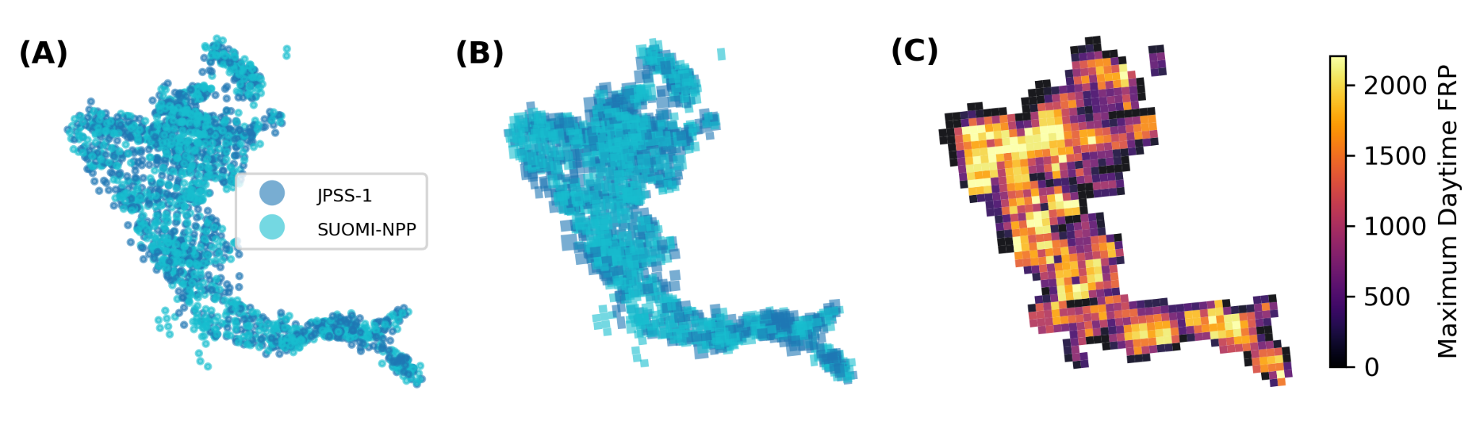

**Figure 2.** Aggregation of VIIRS active fire detections (AFD) onto a regular grid for the Williams Fork Fire (2020). (**A**) Pixel centers of AFD from both satellites (S-NPP and JPSS-1); (**B**) Pixel ground area based on swath position (relative nadir position); (**C**) Maximum FRP based on fractional overlap aggregation.

## 2.4. Composite Burn Index (CBI)

We created burn severity rasters for each wildfire in the census using pre- and post-fire Landsat 8 imagery following methods from Parks et al. (2019) in the Google Earth Engine cloud-compute platform (Gorelick et al., 2017). While this method produces a variety of burn severity metrics based on spectral indices, we retained only the bias-corrected CBI (CBIbc) for analysis as this metric adjusts values at the extreme low/high ends of the range, better quantifying the variability in burn severity (Parks et al., 2019a). We calculated zonal statistics of CBIbc within our 375 m2 grid cells to align the spatial scale with FRP aggregations. Specifically, the average, standard deviation, and percentiles were calculated for each grid cell. For analysis, we use the 90th percentile of CBIbc which emphasizes higher burn severity while still accounting for some within-cell variability.

## 2.5. Forest Composition and Structure

To assess the influence of forest species composition and structure on FRP and CBIbc, we gathered information from the ca. 2016 USFS TreeMap (Riley et al., 2022). TreeMap imputes Forest Inventory and Analysis (FIA) plot identifiers onto LANDFIRE (Picotte et al., 2019) pixels (30 m2 spatial resolution) based on a set of LANDFIRE biophysical characteristics including topography, vegetation type, and disturbance (Riley et al., 2021, 2022). The FIA is a nationally consistent forest inventory monitoring program providing information about forest composition and structure across a wide variety of forest types and environmental site conditions (Gray et al., 2012). While representing a sparse network of FIA plots, the TreeMap demonstrates good agreement with existing vegetation types and field measurements, enabling estimation of forest characteristics at the landscape scale (Riley et al., 2022). We use the TreeMap to, (i) identify gridcell majority forest type by percentage of the gridcell area, and (ii) assess species-specific structure metrics for all species likely present from the TreeMap *Tree Table*. Method (ii) thus includes potential understory components not captured by the majority forest type assigned to each TreeMap pixel. Additionally, the gridcell average forest canopy percent was calculated using the TreeMap canopy percent attribute (*CANOPYPCT*) included in the latest release (Riley et al., 2022). The two primary aggregations are described in more detail in the sections below.

### 2.5.1. Dominant forest cover

We calculated the dominant forest type in each gridcell based on the proportion of TreeMap pixels.

The algorithmic forest type code (*FORTYPCD*) assigns a single forest type to each TreeMap pixel based on the imputed FIA plot information. The FORTYPCD closely aligns with LANDFIRE existing vegetation type (EVT), providing an assignment of the most likely forest type for that pixel. Based on common co-occurring species in the Southern Rockies, we collapsed some *FORTYPCD* into groups. For example, Engelmann spruce and subalpine fir were grouped into *Spruce-fir* and pinon and juniper types into *Pinon-juniper* (**Table SX**). For each gridcell, we calculated the percent cover of all forest types measured as the proportion of pixels in each type.

We calculated the percent cover for all forest types within each gridcell and identified forest types making up 97% of the total forested area by calculating the proportion of forest types in each grid cell.

The predominant forest types included ponderosa (28%), lodgepole (26%), spruce-fir (16%), quaking aspen (11%), mixed-conifer (10%), pinon-juniper (8%), and oak-woodland (6%) (**Figure S1a**). For each grid, the percent cover of each of these species groups was calculated from pixel counts within grids, and the majority type was identified as predominant. The distribution of grid cells with dominant species varies relative to the landscape proportion, where, for example, grids dominated by mixed conifer, oak-woodland and pinon-juniper are rare and lodgepole or ponderosa are more common (**Figure S1a**).

### 2.5.2. Species-specific structural metrics

Species-specific structural metrics were derived for all species present in a gridcell based on the TreeMap *Tree Table*, which provides rich information about the size, species, and status (live/dead) of all measured trees based on the imputed FIA plot data (Gray et al., 2012; Riley et al., 2021, 2022). These summaries thus include potential understory composition and mixed-forest pixels, which are important for understanding fire behavior and other ecological processes (Krebs et al., 2019). Instead of the *FORTYPCD*, we counted the frequency of FIA plot identifiers (*TMID*) from TreeMap pixels then linked these to the *Tree Table* to retrieve the individual tree information. We limit forest species to those which align with our predominant forest types described in *Section 2.5.1* and which would be commonly observed in Southern Rockies forests. We calculated the live and dead TPP and BA summed across individual species for each FIA plot and multiplied by the number of pixels assigned that plot identifier in the grid. The TPP was estimated by multiplying the *TPA_UNADJ* attribute in the *Tree Table* for each species by a conversion factor for acres/pixel (Riley et al., 2022). BA was calculated by using the diameter (in) of individual trees in the *Tree Table* multiplied by the number of trees it represents per pixel (*i.e.*, TPP), per the FIA sampling design (Gray et al., 2012; Riley et al., 2022). Using BA and TPP, we also calculated the quadratic mean diameter (QMD) for each plot and species. The QMD represents a measure of average tree diameter that is commonly used in forestry practices and is useful for characterizing the size structure of trees (Curtis & Marshall, 2000). High values of QMD represent forests which are dominated by a few large individuals whereas small values represent forests dominated by a larger number of small trees. These metrics were then aggregated to the grid level to determine the contributing proportion of each species to the total dominance (BA) and abundance (TPP) of forest types within each grid (**Figure S1b**). Finally, each grid was assigned a diversity score using the Shannon diversity index based on abundance (H-TPP) to assess the structural richness and evenness of forest types (Neumann & Starlinger, 2001). We calculated the H-TPP by summing the product of each species' TPP proportion within the grid and the natural logarithm of that proportion, giving a higher value when there is a greater variety of species.

## 2.6. Climate and Topography

Topographic characteristics were obtained from the USGS 3DEP program ⅓ arc-second (~10 m) digital elevation model (DEM) (*ref*). We included first order topography variables from the DEM, including elevation and slope, and second order derivatives, including the Topographic Position Index (TPI) and Continuous Heat Insolation Load Index (CHILI) (Theobald et al., 2015). For all topography variables, we calculate the grid-level average values. To characterize daily fire weather conditions, we gathered vapor pressure deficit (VPD), wind speed, and energy release component (ERC) from gridMET, which provides nominally high-resolution (~4 km) gridded meteorological data on a daily basis from 1979-current (Abatzoglou, 2013). Grids were spatially grouped by the first day-of-burn based on VIIRS detections to form the spatial unit for gridMET variables. Specifically, the average VPD, ERCdv, and wind speed for day-of-burn and the deviation from the 15-year average ERC (ERCdv) was calculated to represent the climatic extremes associated with fire growth. The 15-year average was used for ERCdv to represent the more extreme fuel dryness in the western U.S. during recent history (Parks & Abatzoglou, 2020).

## 2.7. Statistical analysis

To assess the influence of predominant forest type and forest species composition and structure on FRP and CBI, we fit Bayesian hierarchical spatial models using the Integrated Nested Laplace Approximation (INLA) framework, implemented in *R-INLA* (R Core Team, 2024; Rue et al., 2009). Unlike traditional Markov Chain Monte Carlo (MCMC) methods, INLA leverages deterministic approximations (Laplace approximations), providing a computationally efficient and flexible alternative for Bayesian inference that has been widely applied in recent years (e.g., Gomez-Rubio, 2020; Niekerk et al., 2019). These models are particularly well-suited for dynamic ecological systems, offering precise inference on spatial processes and rapid computation of posterior distributions for model covariates (Beguin et al., 2012; Engel et al., 2022; Niekerk et al., 2019; Sadykova et al., 2017). *R-INLA* allows fitting complex hierarchical models to account for structured and unstructured latent random effects such as fire-level variability, temporal day-of-burn effects, and complex spatial effects. We fit separate models for both FRP and CBI to address three primary goals; 1) determine the effect of predominant forest type on radiative energy and burn severity *relative to aspen*, 2) test how forest type-specific composition and structure metrics influence FRP and CBI, and 3) determine how aspen co-occurrence and dominance influences FRP and CBI across predominant forest types both with and without mediating effects of fire weather. These approaches are described in greater detail in the sections below.

### 2.7.1. Effect of dominant forest cover relative to aspen

We assessed the effect of predominant forest type (*i.e.*, where *FORTYPCD* was >50% of forest cover in the grid) on cumulative FRP and 90th percentile CBI, establishing the intensity and severity of predominant species *relative to aspen* as the baseline. Because aspen was used as the baseline forest type, an additional fixed effect was included in this model indicating fire-level aspen presence. In this approach, only grids which are majority forested (>50%) and where at least 20% of forested pixels were of the predominant type. We removed *oak-woodland* forest type due to insufficient number of grids where it was predominant. Additionally, only fires which had at least 10 grids after filtering were included to help stabilize spatial modeling (see *Section 2.7.5*), resulting in 31,209 grids across 82 fire events.

### 2.7.2. Effect of composition and structure

We assessed the effect of forest composition and structure on FRP and CBI using the forest type-specific metrics including proportional live BA, QMD, tree height (m), and diversity (H-TPP). In this approach, the contributions of all co-occurring forest types estimated to be present in a grid were explicitly incorporated through interaction terms linking forest types to their grid-level metrics from the TreeMap *Tree Table*. Thus, estimated understory or co-occurring forest types from FIA plot data are included in this model as opposed to the single *FORTYPCD* assigned to the pixels. We retained co-occurring forest types for each grid if either their proportion BA or TPP was greater than 1% to eliminate noise in small proportions. Again, *oak-woodland* was removed to align better with the first approach and only fires with at least 10 grids were retained.

### 2.7.3. Influence of quaking aspen co-dominance and fire weather

To test the influence of aspen co-occurrence and dominance on FRP and CBI, we identified fires which had at least 1% pre-fire aspen cover (N=53). Aspen dominance was measured as the proportion of live BA based on the *Tree Table* summary. An interaction term between the grid-level predominant forest type and aspen dominance was constructed to test the effect of aspen co-occurrence across major forest types (including where aspen was predominant). To test the influence of fire weather on mediating these relationships, an additional interaction term was set with VPD (*fortypcd:aspen dominance * VPD*). As such, we show the influence of aspen dominance both with and without VPD-mediation. An additional fixed effect term was included to adjust for grid-level aspen presence.

*2.7.4. Model parameters*

For all models, we accounted for grid-level fixed effects of canopy cover, fire weather (VPD, wind speed, and ERCdv), topography (elevation, slope, TPI, and CHILI), fire-level and day-of-burn random effect and spatial dependence (see *Section 2.7.1* below). The models were parameterized using the gaussian family for FRP and gamma for CBI based on the observed distribution of the response variables. Prior specification was done to allow for flexibility in model estimates based on expectations in the data and comparison of model fit statistics, specifically Watanabe-Akaiki information criterion (WAIC) and conditional predictive ordinates (CPO), two measures of model robustness and predictive power, respectively, commonly used to compare model outputs in *R-INLA* (Gomez-Rubio, 2020). For FRP models only, additional terms were included to represent the total contributing detection count, overlap percentage, and the proportion of daytime observations of VIIRS active fire detections within each grid to account for the aggregation methods (see *Section 2.3.2*). Prior to fitting models, we tested correlations between predictor variables using a Spearman correlation coefficient, allowing for non-linearity in relationships.

### 2.7.1. Spatial mesh grid

Wildfires are inherently spatially-dependent processes, requiring careful assessment of model covariates. To account for these spatial processes, we implemented the Stochastic Partial Differential Equation (SPDE) approach, which is a key innovation within the INLA framework for modeling spatial processes (Lindgren et al., 2011). The SPDE efficiently approximates continuous spatial Gaussian random fields (GRFs) using sparse precision matrices, linking GRFs to Gaussian Markov Random Fields (GMRFs) through a triangulated mesh representation (Bakka et al., 2018). We developed a spatial mesh for the Southern Rockies designed to reflect the expected within-fire spatial processes and minimize the influence of between-fire dependence. The mesh parameters, including maximum edge, cutoff, offset, and priors were chosen to balance computational efficiency with observed spatial process based on fire-specific semivariograms fit using the *gstat* R package (Gräler et al., 2016). More detailed information about the mesh creation and SPDE model definitions can be found in the supplement and in Figure 3 in *Section 3.1*.

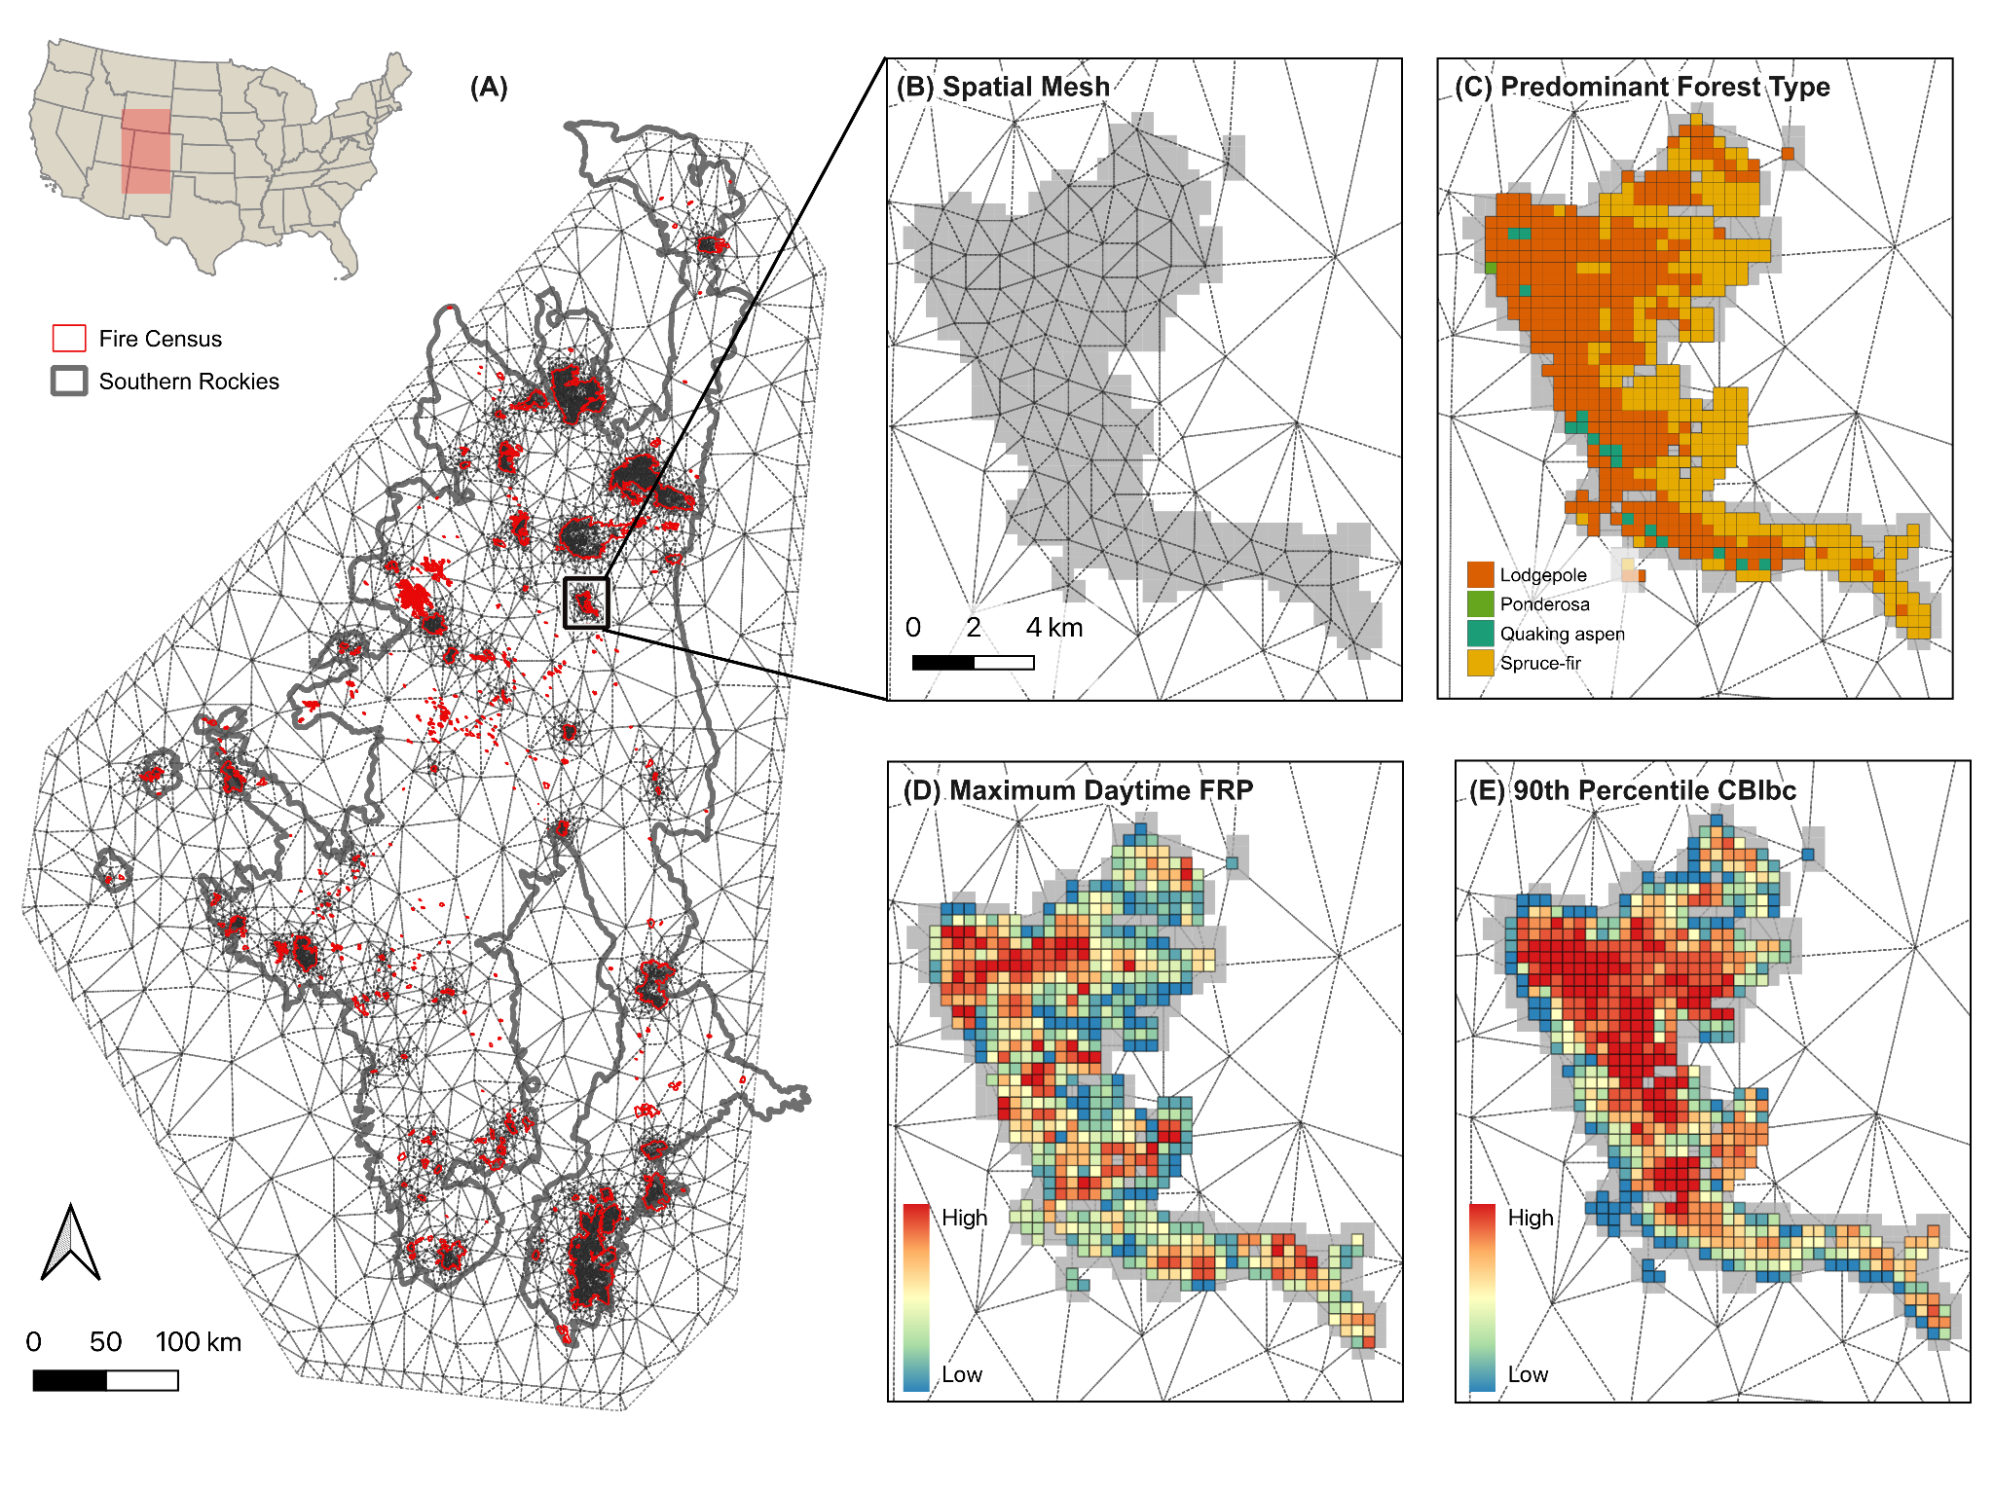

**Figure 1.** Southern Rockies study area with spatial mesh and highlight for the Williams Fork Fire, CO (2020). **(A)** Full spatial mesh for the study region with all fire census in red. The mesh is designed to capture within-fire variability while relaxing the intra-fire spatial dependence as seen by the wider triangular mesh between fire events. **(B)** Spatial mesh for the Williams Fork Fire, CO (2020) showing the within-fire spatial dependence with smaller triangles, set at a minimum distance of ~1 km between nodes. **(C)** Predominant forest type aggregated to gridcells, defined by the pixel count majority from TreeMap FORTYPCD. **(D)** Aggregateddaytime maximum FRP (W/km2). Where grids remain gray, there were no daytime observations. **(E)** Observed spatial effect of FRP for the predominant forest type model (see *Section 3.1*). FRP exhibits tight spatial clustering and the spatial dependence is strongest with ~1.4 km indicating fine-scale spatial dependence. The Williams Fork Fire burned approximately 14,833 acres and emitted a cumulative FRP of 3071.13 W/km2 (ranked 14th overall) based on VIIRS active fire detections.

# Results

## 3.1. Effect of dominant forest type relative to aspen

In the Southern Rockies, dominant forest types influenced cumulative FRP and 90th percentile CBI *relative to aspen*, demonstrated by the posterior distribution of effects (**Figure 2**). For FRP, lodgepole-dominated gridcells showed the highest relative effect, with a 34% higher FRP than aspen-dominated gridcells. Douglas-fir and spruce-fir forest types also showed a significant positive effect relative to aspen, though the credible intervals near zero indicating a weaker positive effect. Ponderosa-dominated gridcells tended towards a lower relative FRP, although the credible intervals (.25 and .95) overlap zero indicating uncertainty in model estimates. Pinon-juniper gridcells exhibited significantly lower FRP compared to aspen-dominated gridcells. For all forest types, the effect on CBI was significant and positive with tighter credible intervals, demonstrating higher certainty in the effects on burn severity relative to aspen. Models were better able to predict CBI than FRP, demonstrated by the higher CPO and lower WAIC. The inclusion of fire-level and day-of-burn random effects and the spatial SPDE model (see *Section 3.1.1* below) significantly improved model fit based on CPO and WAIC (**Table S2**). Significant positive effects emerged for VPD, ERCdv, slope, TPI, and grid-level mean canopy percent highlighting the importance of these factors in predicting fire behavior (**Table S3**). Steeper slopes and localized high points like ridges (higher TPI values) increase FRP and CBI. Similarly, higher VPD and ERCdv resulted in higher FRP and CBI, though with wider credible intervals, and the effect of wind speed was highly uncertain (**Figure SX**). For FRP models, inclusion of VIIRS aggregation attributes (percent cumulative overlap, detection count, and proportion of daytime detections) significantly improved model fit.

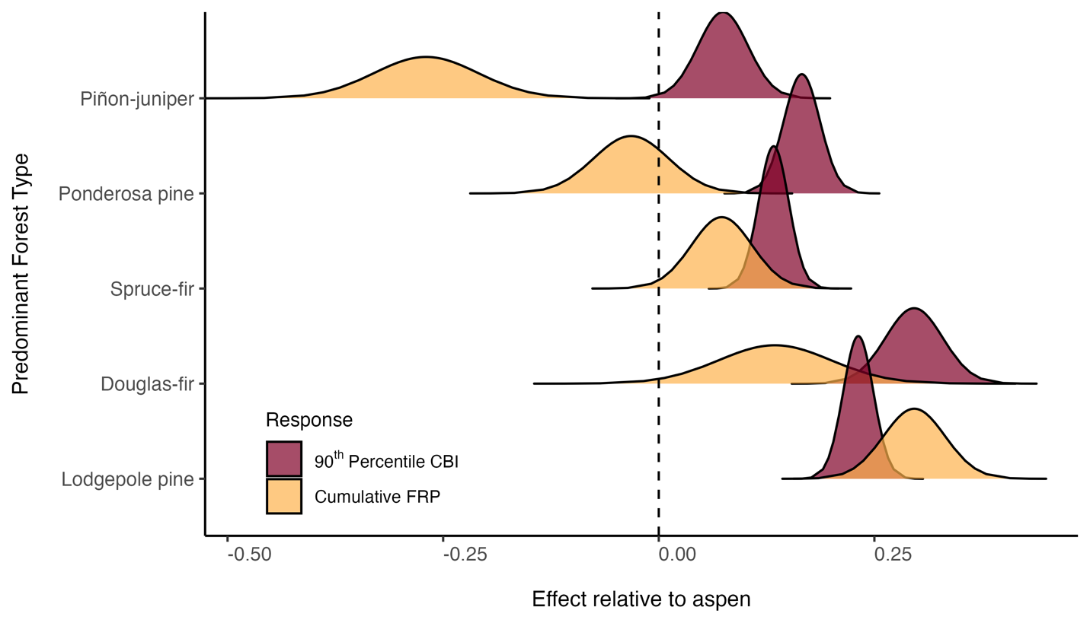

**Figure 2.** Posterior distributions of effects of predominant forest type (>50% of gridcell) on maximum daytime FRP and 90th percentile CBI *relative to aspen*. Lodgepole, Douglas-fir, and ponderosa forest types had significant positive effects on both FRP and CBI. Spruce-fir forests had a slight positive effect with the lower credible interval passing zero. The effects of pinon-juniper relative to aspen are highly uncertain for FRP but were significant and positive for CBI. All forest types demonstrate a significant positive effect on CBI, indicating higher burn severity relative to aspen.

### 3.1.1 Spatial patterns in FRP and CBI

Substantial spatial structure emerged in different ways for both FRP and CBI, described by the SPDE structured random effects model implemented in *R-INLA* (**Figure 3**). Semi variogram analysis provided an initial assessment of the expected spatial range for both responses (**Figure SX**), suggesting that the expected mean range for FRP was ~2.2 km and ~2.9 km for CBI. As such, the maximum edge length in the spatial mesh grid was set to 0.01 degrees (~ 1.1 km) in order to capture potential fine-scale spatial patterns. The SPDE results indicate moderate alignment with these expectations alongside fixed and random effects, with slight differences. For FRP, the mean effective range of spatial correlation is 0.014 degrees (~1.4 km), suggesting a fine-scale clustering and influence of localized conditions unexplained by fixed or random effects (**Figure 3E**). A relatively large standard deviation (mean 0.769) indicated moderately strong spatial variation in FRP and residual spatial effects left unexplained by the model. In the case of CBI, the effective range of spatial correlation increases to 0.078 (~7.8 km), suggesting more broad-scale spatial patterns in burn severity compared to FRP. With a far lower standard deviation (mean 0.088), the spatial variation in CBI is significantly lower than for FRP and may be better explained by the fixed and random effects such as day-of-burn, forest type, fire weather, and topography.

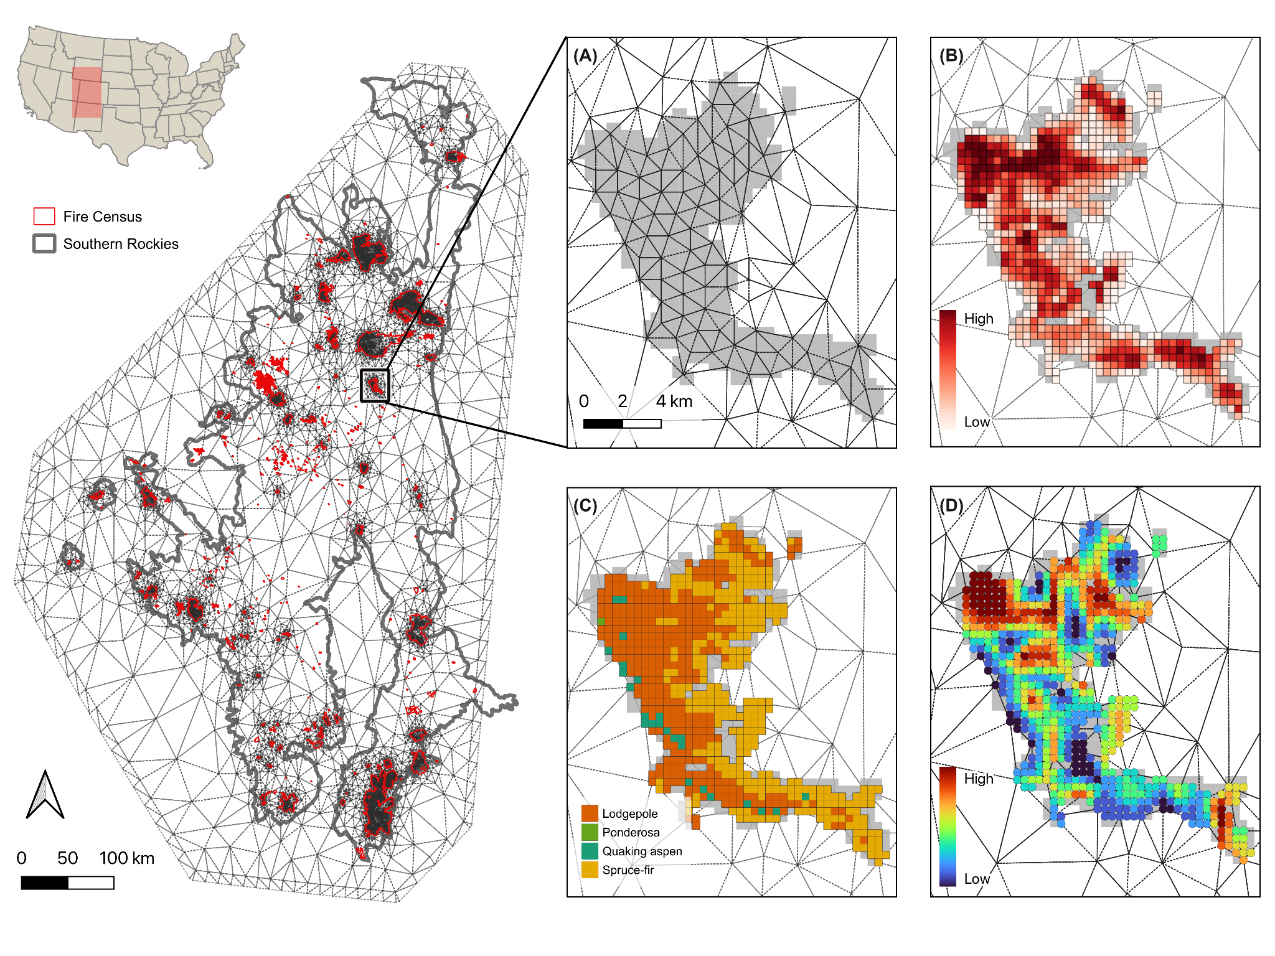

**Figure 3.** Southern Rockies spatial mesh grid example grid data for the Williams Fork Fire, CO (2020). **(A)** Full mesh grid covering the Southern Rockies study region with all fire census data in red. The spatial mesh is designed to capture within-fire variability while relaxing the intra-fire spatial dependence as seen by the wider triangular mesh between fire events. **(B)** Spatial mesh grid for the Williams Fork Fire. The mesh grid captures within-fire spatial dependence with a tighter triangle mesh around data points, set at a minimum distance of ~1 km between nodes. **(C)** Daytime maximum FRP (W/km2). Where grids remain gray, there were no daytime observations. **(D)** Grid-level predominant forest type, defined by the pixel count majority from TreeMap FORTYPCD. **(E)** Observed spatial effect of FRP for the predominant forest type model (see *Section 3.1*). FRP exhibits tight spatial clustering and the spatial dependence is strongest with ~1.4 km indicating fine-scale spatial dependence. The Williams Fork Fire burned approximately 14,833 acres and emitted a cumulative FRP of 3071.13 W/km2 (ranked 14th overall) based on VIIRS active fire detections.

## 3.2. Effect of composition and structure

We tested the influence of composition and structure metrics on FRP and CBI while accounting for fire weather, topography, grid-level mean canopy percent. Grid-level composition was measured using forest type diversity (H-TPP) and proportional live BA (hereafter *dominance*) for all forest types co-occurring in a grid. Structural metrics included the type-specific QMD and tree height. Each forest type represented in the grid was interacted with composition and structure metrics derived from the Tree Table based on FIA plot-level information (see *Section 2.5.2*). Again, separate models were fit for FRP and CBI with fixed and random effects and VIIRS aggregation information (for FRP). The same SPDE mesh was applied to account for the spatial dependence in effects. The credible intervals of the posterior distributions are tighter for the CBI model than for FRP, and the conditional predictive ordinates (CPO) indicated better predictive power for CBI models (**Table S3**). Again, the spatial effects operated at a much smaller range for FRP (~1.4 km) compared to CBI (~7.8 km) and with higher residual variance, indicating that CBI is better captured by the fixed, random and spatial effects models. The results from each composition and structure metric are described in greater detail below.

### 3.2.1. Forest type dominance

The dominance of forest type influenced FRP and CBI with varying levels of certainty (**Figure 4**). Quaking aspen pinon-juniper showed the strongest negative effect on both FRP (**Figure 4a**) and CBI (**Figure 4b**). As aspen dominance increases, both FRP and CBI were significantly lower than most other forest types. A similar pattern in dominance emerged for spruce-fir, although with a smaller relative effect. For both ponderosa and lodgepole, dominance slightly increased FRP while the effects on CBI were uncertain (credible intervals passing zero). Mixed-conifer dominance had a strong positive effect on burn severity although its effect on FRP was also uncertain.

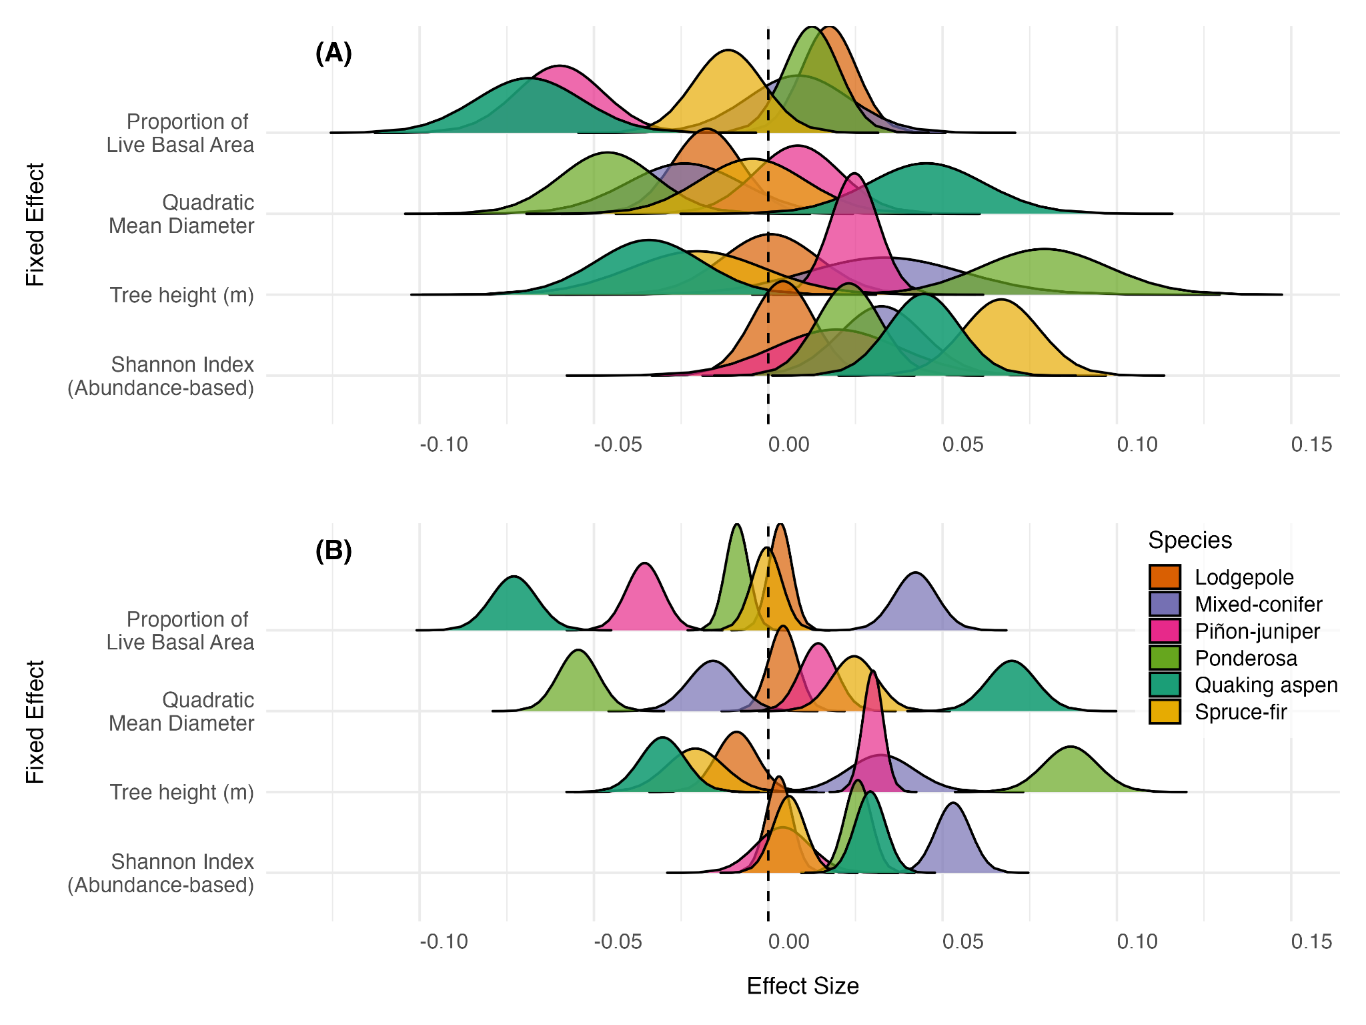

**Figure 4.** Posterior distribution of effects for forest type-specific composition and structure metrics on (**A**) FRP, and (**B**) CBI. We assessed the proportion of grid-level forest type basal area, forest-specific mean quadratic diameter and tree height, and the relationship between majority forest type and diversity measured using the Shannon diversity index (H). Posterior distributions which overlap zero are uncertain. Quaking aspen demonstrates strong and significant (credible intervals not passing zero) effects for all four metrics.

### 3.2.2. Forest type QMD and tree height

Quaking aspen-specific QMD had a strong positive effect on FRP and CBI, suggesting aspen forests which are dominated by few but large individuals may exhibit greater intensity and severity (**Figure 4a, 4b**). Except for ponderosa, where QMD had a significant *negative* effect, all other forest types were uncertain with credible intervals overlapping zero. Ponderosa-specific QMD demonstrated an opposite effect relative to aspen, where forests dominated by few large individuals tended to exhibit lower FRP and CBI. The influence of tree height on FRP was less certain (wider credible intervals) but significant effects emerged for quaking aspen, pinon-juniper, and ponderosa. For quaking aspen, increasing tree height tends to decrease FRP where the opposite is true for pinon-juniper and more so for ponderosa. Tree height has a more profound effect on CBI, particularly for both quaking aspen and ponderosa, which again demonstrate opposite relationships.

### 3.2.3. Forest type diversity

For all forest types, H-TPP increased both FRP and CBI (**Figure 4**). This effect was less strong and uncertain for lodgepole and pinon-juniper forests but profound for FRP in spruce-fir and for CBI in mixed-conifer and quaking aspen grids, indicating that as the diversity of forest types increased, both FRP and burn severity tended to increase. The credible intervals for H-TPP were tighter for FRP models than for other variables, indicating more confidence in model estimates.

## 3.3 Influence of aspen co-occurrence across major forest types

Quaking aspen co-occurrence and dominance relative to predominant forest types influenced FRP and CBI, although effects were mediated by VPD in some cases (**Figure 5**). Where quaking aspen is predominant, increasing proportional live BA significantly decreases FRP (mean effect -0.21) and CBI (mean effect -0.23). However, there is a strong VPD-mediating effect, where the influence of aspen dominance on reducing FRP and CBI either diminishes greatly (CBI, **Figure 5b**) or becomes slightly positive (FRP, **Figure 5a**). In both cases, the credible intervals for the VPD-mediated effect slightly overlap zero, indicating a more negligible effect. Similarly, in lodgepole-predominant grids the effect of increasing aspen dominance on FRP was significant and negative, with a moderate diminishing influence of VPD-mediation. Conversely, in spruce-fir, ponderosa, and pinyon-juniper predominant grids, the VPD-mediating effect on FRP and CBI actually improved the effect of aspen dominance (*i.e.*, decreasing effect, reduction in the response variables). In ponderosa-dominated grids, aspen dominance tends to decrease CBI *only* when mediated by VPD, whereas it has a slight positive effect without mediation. The same is true for spruce-fir dominant grids and the effect on FRP. For pinyon-juniper and mixed-conifer predominant grids, which are relatively rare (Figure S1), the effects of aspen dominance exhibited extreme credible intervals overlapping zero for the FRP models. These forest types rarely co-occur with aspen in great proportions (**Figure SX**), which helps explain the wide credible intervals and uncertain estimates. Again, the credible intervals were tighter for the CBI model and the CPO was significantly higher (Table S2), suggesting better predictive power for CBI compared to FRP.

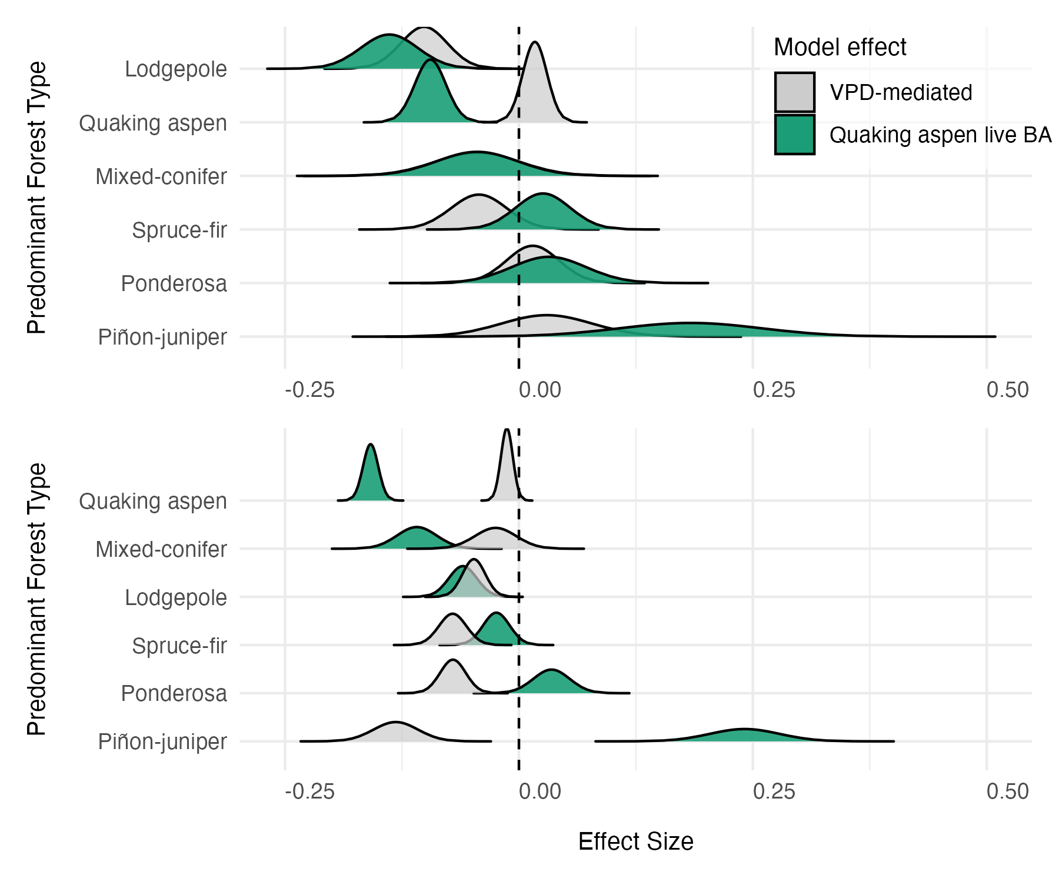

**Figure 5.** Posterior distribution of effects on (**A**) FRP, and (**B**) CBI, for the influence of quaking aspen *dominance* relative to co-occurring predominant forest types with and without VPD mediation. Grey distributions represent the VPD-mediated effect which was modeled as an interaction term (*forest type:aspen dominance * VPD*). For both models, terms were included to account for other fire weather, topography, fire-dependent random effects, day-of-burn temporal random effects, and spatial effects. Additional terms accounting for VIIRS detection aggregation were included for the FRP model (see *Section 2.7*).

# Discussion

Significant differences in the effect on FRP and CBI relative to aspen emerged across predominant forest types in the Southern Rockies during recent (2017-2023) wildfires. Lodgepole, mixed-conifer, spruce-fir, and ponderosa forests tend to exhibit higher fire intensity and severity relative to aspen forests while accounting for weather, topography, fire-level and temporal random effects and spatial dependence (**Figure 2, Figure 3**). The spatial effects of FRP and CBI occur at different ranges, with FRP demonstrating tighter spatial clustering of effects at ranges of ~1.2 km and CBI at ranges of ~7.8 km. In both cases, evidence of spatial dependence was strong and addition of SPDE models influenced the fixed effects and model performance estimates in meaningful ways. Additionally, we found that the relative composition and structure of forest types had varying effects on FRP and CBI, with live BA, tree height, and QMD elucidating these differences (**Figure 4**). Importantly, quaking aspen effects were significant (credible intervals not passing zero) in all four metrics for both models of composition and structure. Finally, the influence of aspen dominance across major forest types demonstrates the ability of aspen to moderate FRP and CBI, especially in lodgepole-dominant grids, although this influence can be VPD-mediated (**Figure 5**). In terms of model performance, CBI models consistently had higher CPO indicating better predictive power of CBI than FRP. Furthermore, the lower residual variance in the spatial model for CBI suggests that forest type, fire weather, topography better predict CBI spatial patterns than they do for FRP. These findings have wide implications for management quaking aspen forests for potential wildfire risk reduction. The methods described herein provide a framework for assessing forest composition and structure effects on satellite-observed fire behavior, which helps inform broader management decisions and assessment of management actions such as fuel treatments. The implications of these findings are discussed in more detail below.

In aspen-dominated grids, for example, a significant reduction FRP and CBI occurs as the proportion of live basal area increases, but when interacting with VPD this effect either becomes insignificant or slightly positive (Figure 5). In the case of lodgepole, VPD had a weaker influence on the capacity for aspen dominance to reduce FRP and CBI. However, in spruce-fir and ponderosa forests, aspen dominance seems to improve its influence in reducing both FRP and CBI, suggesting that the presence and dominance of aspen is more influential under certain VPD conditions. In terms of model performance, CBI models consistently had higher CPO indicating better predictive power of CBI than FRP. Furthermore, the significantly lower residual variance in the spatial model for CBI suggests that forest type, fire weather, topography better predict CBI spatial patterns than they do for FRP. These findings have wide implications for management of quaking aspen forests for potential wildfire risk reduction. The methods described herein provide a framework for assessing forest composition and structure effects on satellite-observed fire behavior, which helps inform broader management decisions and assessment of management actions such as fuel treatments.

## 4.1. Quaking aspen moderates fire intensity and severity, but this effect may be mediated by VPD and forest structure

Quaking aspen co-occurrence and dominance had a strong moderating effect on both FRP and CBI , especially in lodgepole forests. In this forest type, increasing aspen dominance, measured as the proportional live BA, significantly reduced both FRP and CBI (**Figure 5**). Importantly, the VPD-mediating effect of aspen dominance is minimal in lodgepole forests compared to other forest types, suggesting that greater proportions of aspen moderate intensity and severity *even under more extreme conditions*. In the case of aspen-predominant grids, greater live BA also had a significant reducing effect on FRP and CBI, although this effect is *significantly* VPD-mediated. This suggests that aspen forests *can* moderate fire intensity and severity except, perhaps, under more extreme fire weather conditions. This finding aligns with simulated potential aspen fire behavior under different weather conditions (DeRose & Leffler, 2014). Moreover, the specific structure of aspen forests may play a role in the moderating effects on both FRP and CBI. For example, aspen forests which are dominated by few large individuals (high QMD) tend to exhibit higher intensity and severity (**Figure 4**). This structure is representative of older, decadent aspen forests which may have limited understory regeneration and are often typified by having a conifer component (Rogers et al., 2014). Additionally, in grids where aspen was predominant, increasing diversity (H-TPP) tended to increase fire behavior, suggesting that understory conifer components or mixed conifer-aspen forest types may be more susceptible to higher fire intensity and severity which is supported in the literature (Shinneman et al., 2013). In spruce-fir and ponderosa forests, the influence of aspen dominance on FRP was uncertain, although significant relationships emerged for CBI. Interestingly, the VPD-mediation suggests that aspen dominance has a greater influence on reducing burn severity under more extreme weather conditions. While aspen co-occurrence and dominance influenced other forest types, it is clear that its codominance with lodgepole has a more significant relative effect on fire behavior. From a management perspective, this is significant as it suggests targeted aspen management and expansion in lodgepole-dominated areas may provide a more influential buffering effect to extreme fire, at least in the Southern Rockies. In some of these forests, future aspen dominance is already expected following compound disturbance interactions (Andrus et al., 2021) although the future of aspen habitat suitability should also be considered (Hart et al., *In Review*). Integrating more fine-scale field measurements of aspen forest structure may help elucidate this relationship further, and the methods presented herein offer one approach for assessing the effect of fine-scale structure on fire intensity and severity using satellite data.

## 4.2. Forest structure effects on fire behavior align with expected fire regime characteristics

Forest type-specific fire regime characteristics emerged when assessing the influence of structural metrics on fire intensity and severity, highlighting the capacity of these methods to understand observed fire behavior from satellite-derived information harmonized with wall-to-wall forest structure data. For example, the interesting relationship between forest-specific QMD and fire behavior corroborates expected fire regime characteristics in both ponderosa and quaking aspen forests. Ponderosa forests have historically evolved with high frequency, low severity/intensity wildfire (*ref*). This expectation assumes a open, park-like structure where large individuals are interspersed with meadows and some regeneration (*ref*). These forests have been particularly impacted by a century of fire-exclusion leading to a forest structure that is more densely packed with potentially smaller individual trees and changing fire behavior (*ref*). The results of this study demonstrate that where ponderosa exhibits higher QMD (*i.e.,* closer to the expected forest structure), FRP and CBI are significantly lower (**Figure 4**). In the case of quaking aspen, an opposite relationship emerges (see *Section 4.1* above). These findings also match expected fire regimes of aspen forests, where stable and seral aspen stands exhibit different characteristics (Shinneman et al., 2013). Importantly, in some regions of the Southern Rockies, fire regimes of aspen forests have been modified greatly by lack of disturbance leading to older, decadent, or seral aspen compositions (Rosenblum, 2015). Our models suggest that these aspen forest types increase FRP and CBI, demonstrated by the effects of QMD and tree height (**Figure 4**). These findings are significant, as the methods herein provide a relatively accurate way to assess the influence of forest structure on *observed* fire behavior; an important consideration when planning fuels treatments or assessing their effectiveness.

## 4.3. Patterns of spatial dependence differ for FRP and CBI

Interesting spatial patterns emerged for both FRP and CBI across fire events. The spatial range of dependence is much smaller for FRP (~1.2 km) than for CBI (~7.8 km). This suggests more localized clustering of effects for FRP compared to more landscape-scale processes of burn severity. The much lower residual variance in the CBI models also indicates the fixed effects, particularly forest type, composition and/or structure, are better able to explain the differences in burn severity. For FRP, significant residual variance in the spatial effect suggests the opposite; forest composition and structure patterns alone cannot explain the spatial dependence of FRP as well. This is significant, as the spatial pattern on FRP is more sensitive to localized conditions unexplained in the present models such as specific live fuel moisture or fine-scale wind patterns. Future work can leverage this information to better predict radiative intensity at localized scales. Despite this, some significant effects of forest type, composition and structure did overcome the spatial dependence in FRP, albeit with wider credible intervals than for CBI. This demonstrates the importance of incorporating spatial structure into analysis of wildfire behavior, especially as it relates to satellite-based measurements. The SPDE models implemented in *R-INLA* were effective for assessing and accounting for spatial dependence and their computational feasibility makes this analysis scalable to wide geographic regions.

## 4.4. Opportunities, limitations and future directions

Broadly speaking, the methods of this study are widely applicable to other regions, forest types, and satellite-derived information. Leveraging FRP as a proxy to fire intensity is underutilized and our results highlight the potential of these data to understand how landscape factors influence fire intensity, an important measure of how difficult a fire will be to control (Keeley, 2009). These data could, for example, be leveraged to monitor fuel treatment effectiveness, the influence of beetle-kill on fire intensity, and understand the influence of more fine-scale measurements of live fuel moisture. The VIIRS data in particular offer an important source of *globally* available FRP information. The aggregation of active fire detections in the present study could also be used to integrate data across sensors, such as VIIRS, MODIS, and GOES, to fill the spatial and temporal gaps in detections. As new satellites come online, such as the FireSat constellation scheduled for 2026, these methods may become more applicable with higher temporal and spatial resolution imagery measuring fire radiative energy.

Of course, limitations exist in our current approach. While we demonstrate that TreeMap information combined with fire behavior metrics aligns with forest type-specific expectations, there is potentially high uncertainty in these data. Our use of aggregation and filtering to keep only species which are likely to occur in the Southern Rockies is crucial, as some FIA plot identifiers in the region belong to plots in California, for example. This eliminates plots which fall outside of the ecoregion and improves our confidence in the *Tree Table* estimates. However, these data still represent a sparse network of field sampling locations, introducing uncertainty into our estimates of forest structure. Future efforts will benefit from integrating our approach with other satellite-based measures of forest type, canopy characteristics, and forest structure (e.g., LiDAR) or fine-scale field-based measurement of forest structure and composition to better define these relationships. For example, high-resolution maps of the distribution of aspen forests (e.g., Cook et al., 2024) and other forest types may improve these models in the future. Additionally, while we do include canopy percent estimates from TreeMap in our models, more accurate observed canopy cover data may help define the relationship between FRP and canopy interception, which has been explored in tropical regions (Roberts et al., 2018) but less so in the arid west. Despite this uncertainty, our results highlight important successes in the integration of satellite-derived FRP and CBI with wall-to-wall forest metrics from TreeMap and the information provided in the *Tree Table* provides unique estimates of understory and mixed-forest composition which have been understudied at landscape scales.

# Conclusion

This study demonstrates the influence of forest composition and structure on fire behavior and elucidates the potential moderating influences of quaking aspen forests on fire intensity and severity in the Southern Rockies. From a management perspective, the expansion of aspen forests may reduce the risk of extreme fire behavior under certain conditions, although this influence is likely mediated by the specific structure of aspen forest and the fire weather conditions. The moderating influence of aspen forests is far more pronounced in lodgepole-dominated areas and targeted management of aspen in these forests is likely to provide a larger benefit of wildfire risk reduction. Given this information, aspen management in lodgepole forests can be targeted to provide a potential buffer in regions near communities where wildfire risk and suppression difficulty are high. This study provides important insights into the effects of not only aspen forests, but other predominant forest types and their structure, on observed fire behavior in the Southern Rockies with implications for wildfire risk reduction and forest management.

# References

# 

# Supplement

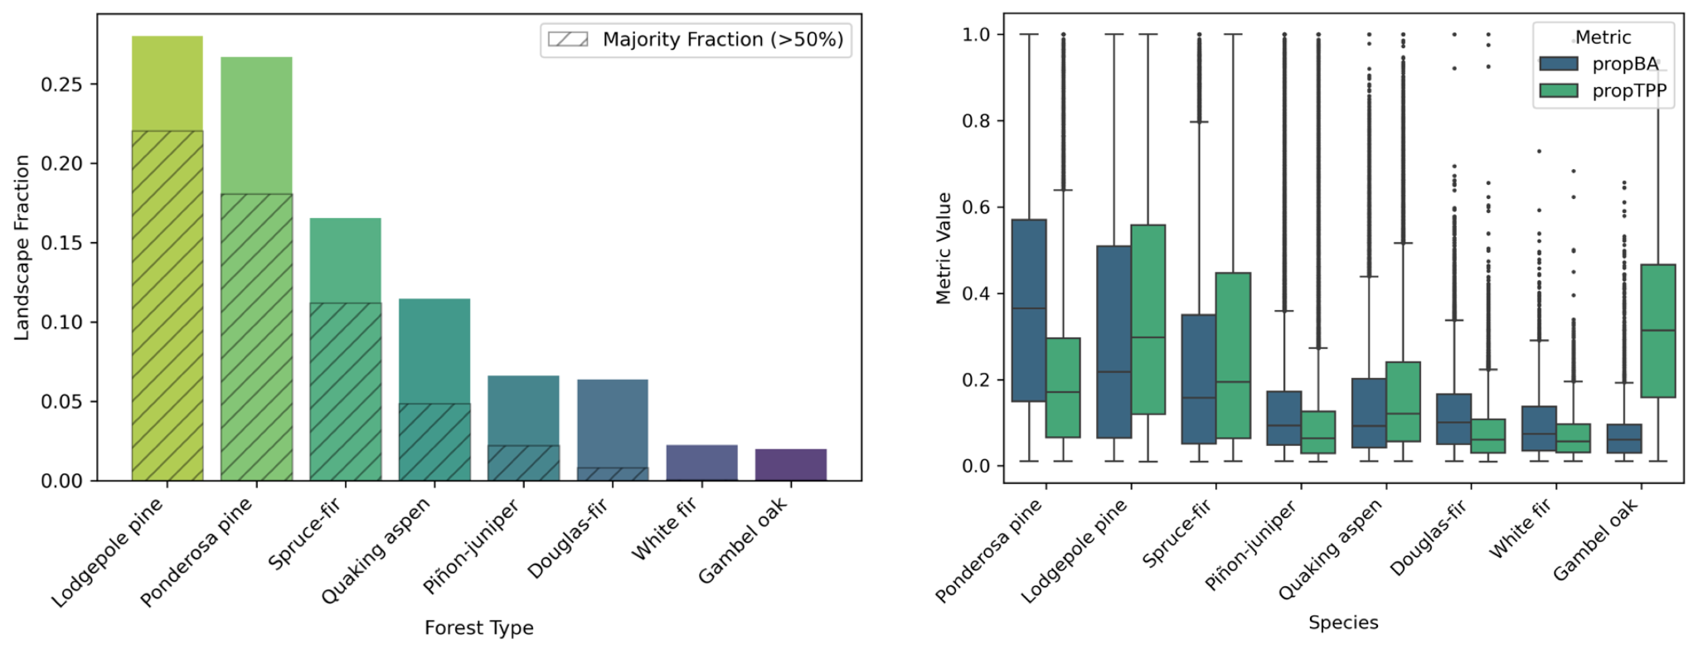

**Figure S1**. (**A**) Predominant forest species groups making up 97% of forested area. Hatching represents the fraction of gridcells where that species is the majority (>50% gridcell forested area). (**B**) Distribution of species structural metrics from the TreeMap *Tree Table* including the proportion of live basal area (BA) and trees/pixel (TPP).

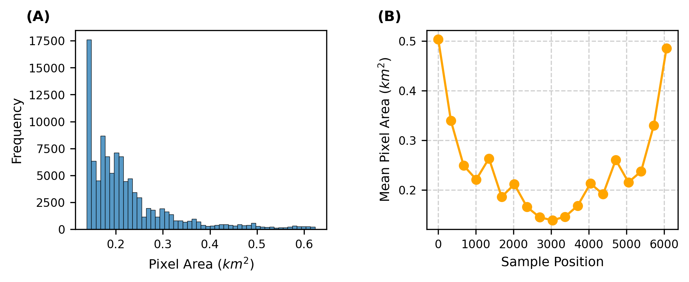

**Figure S2.** (A)Distribution of pixel ground area in square kilometers from VIIRS active fire detections. (B) The mean pixel ground area at each swath sample location. The further off-nadir a pixel is, the greater its ground area.

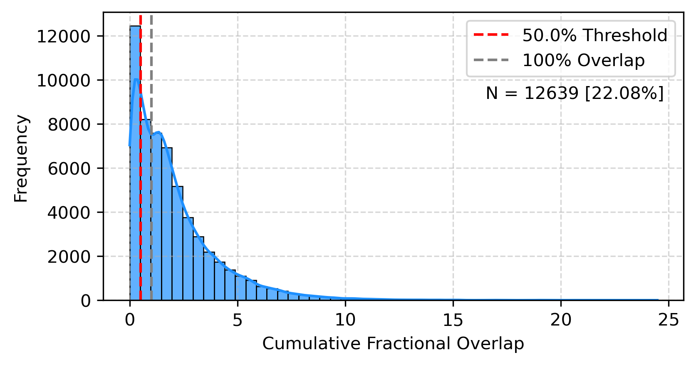

**Figure S3.** Distribution of VIIRS pixel area overlaps with the regular 375 m2 grid of the Southern Rockies showing the cutoff value (>50% gridcell overlap) as a red dashed line and the 100% overlap threshold as a dashed grey line. Only gridcells with *at least* 50% overlap with VIIRS detections were retained for the analysis to limit the contributions of gridcells with very small fractional overlap. 12,639 gridcells were removed from the analysis.

**Table S1.** Statistics calculated for FRP aggregate grid cells.

|  |  |  |
| --- | --- | --- |
| Name | Abbreviation | Some statistic (could do by species) |
|  |  |  |
|  |  |  |

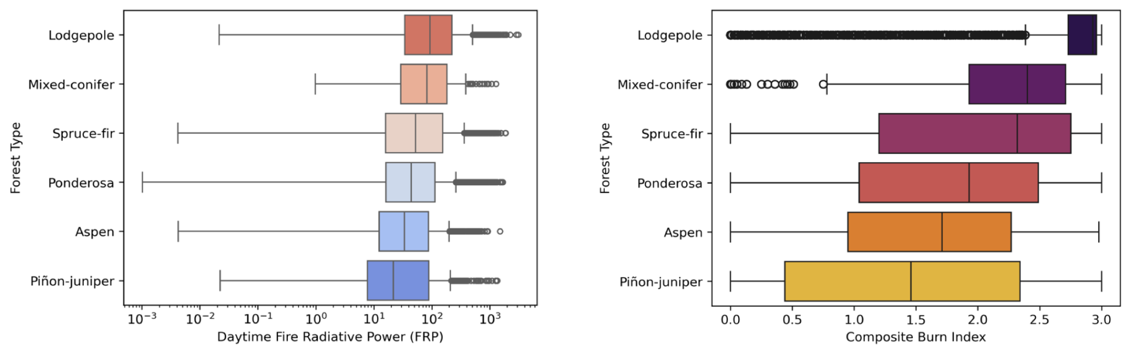

**Figure X.** Distribution of (A) Fire Radiative Power, and (B) Composite Burn Index across major forest types.

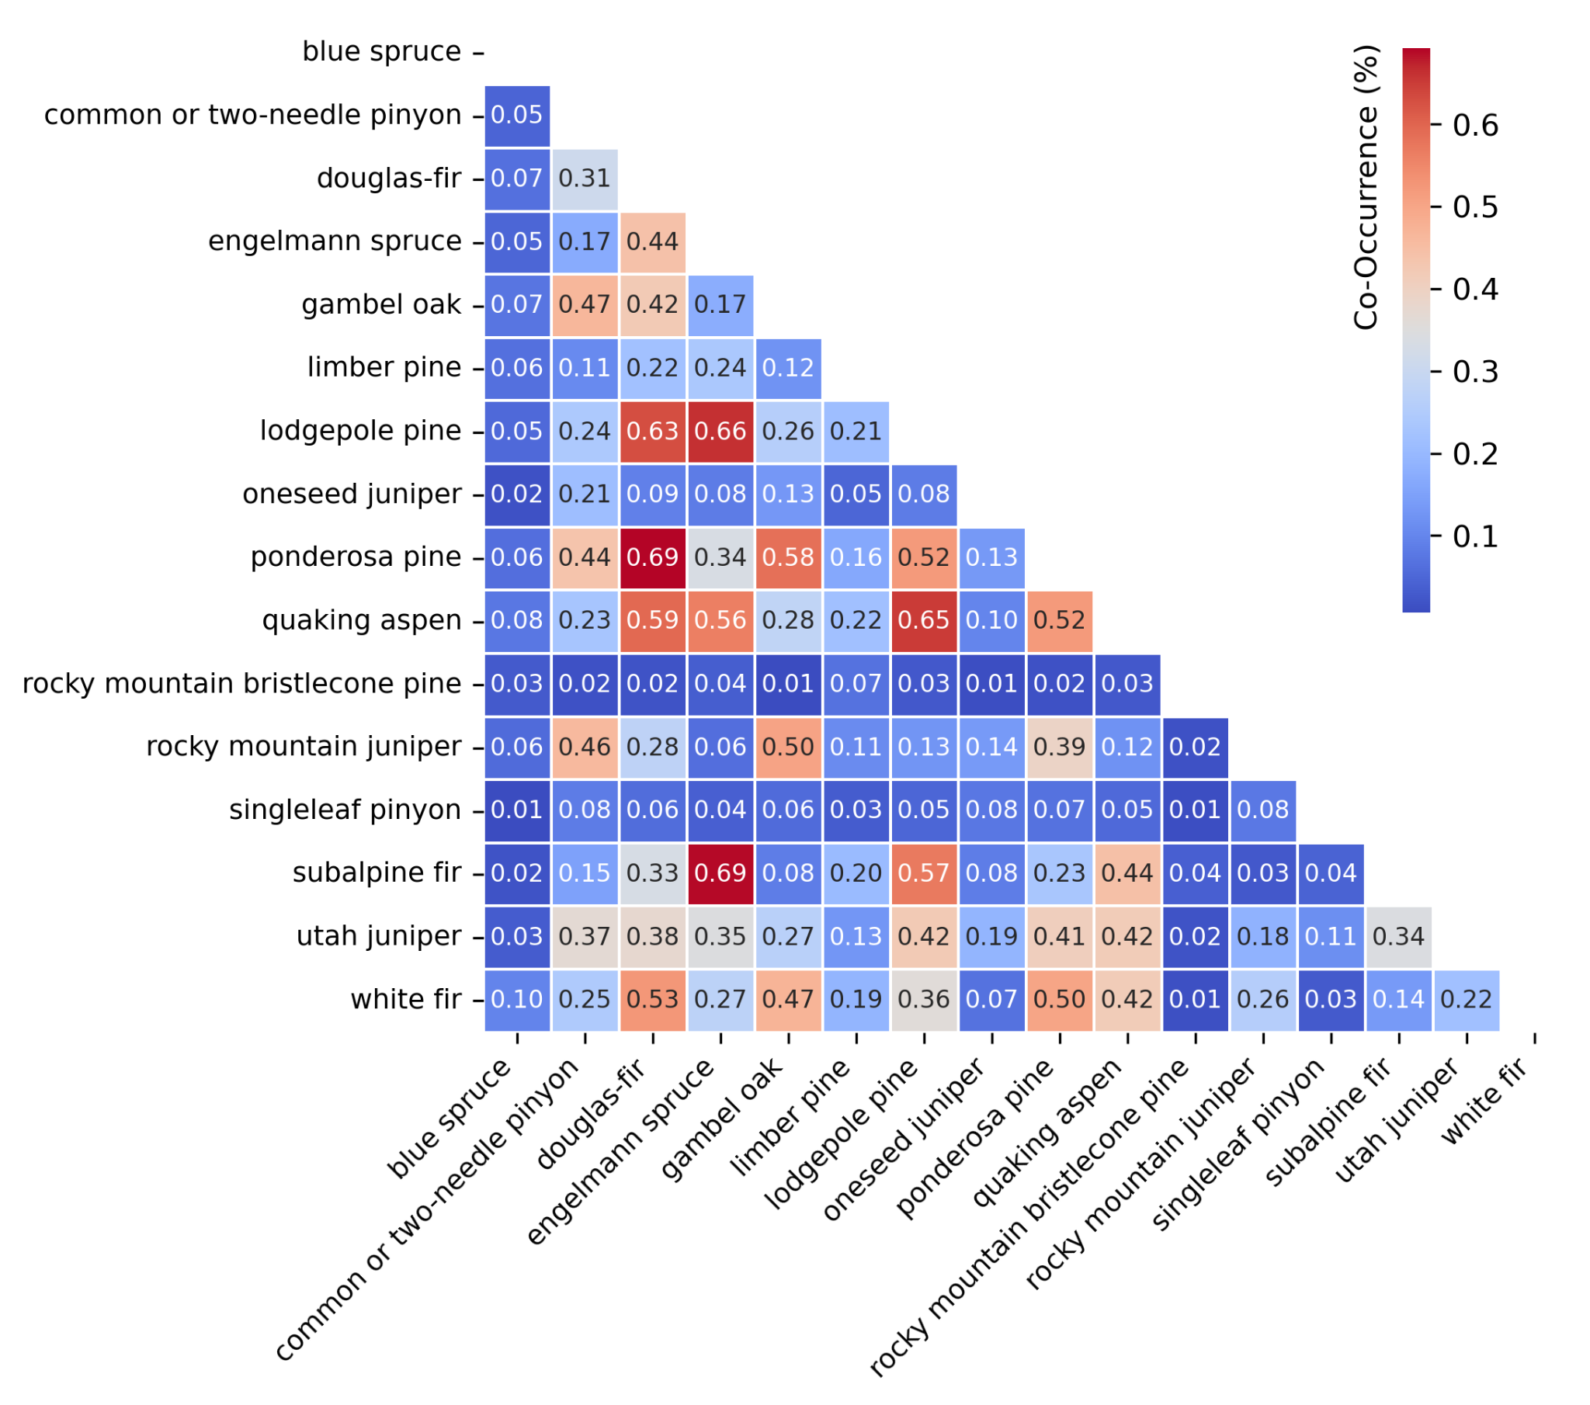

**Figure SX.** Observed species co-occurrence matrix from the TreeMap Tree Table for all forest species considered to be common in the Southern Rockies.

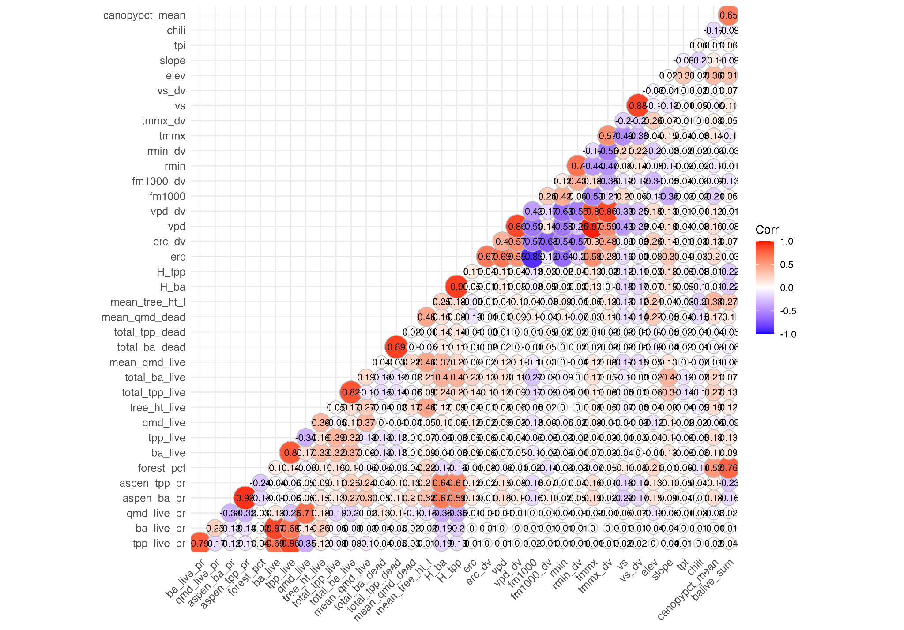

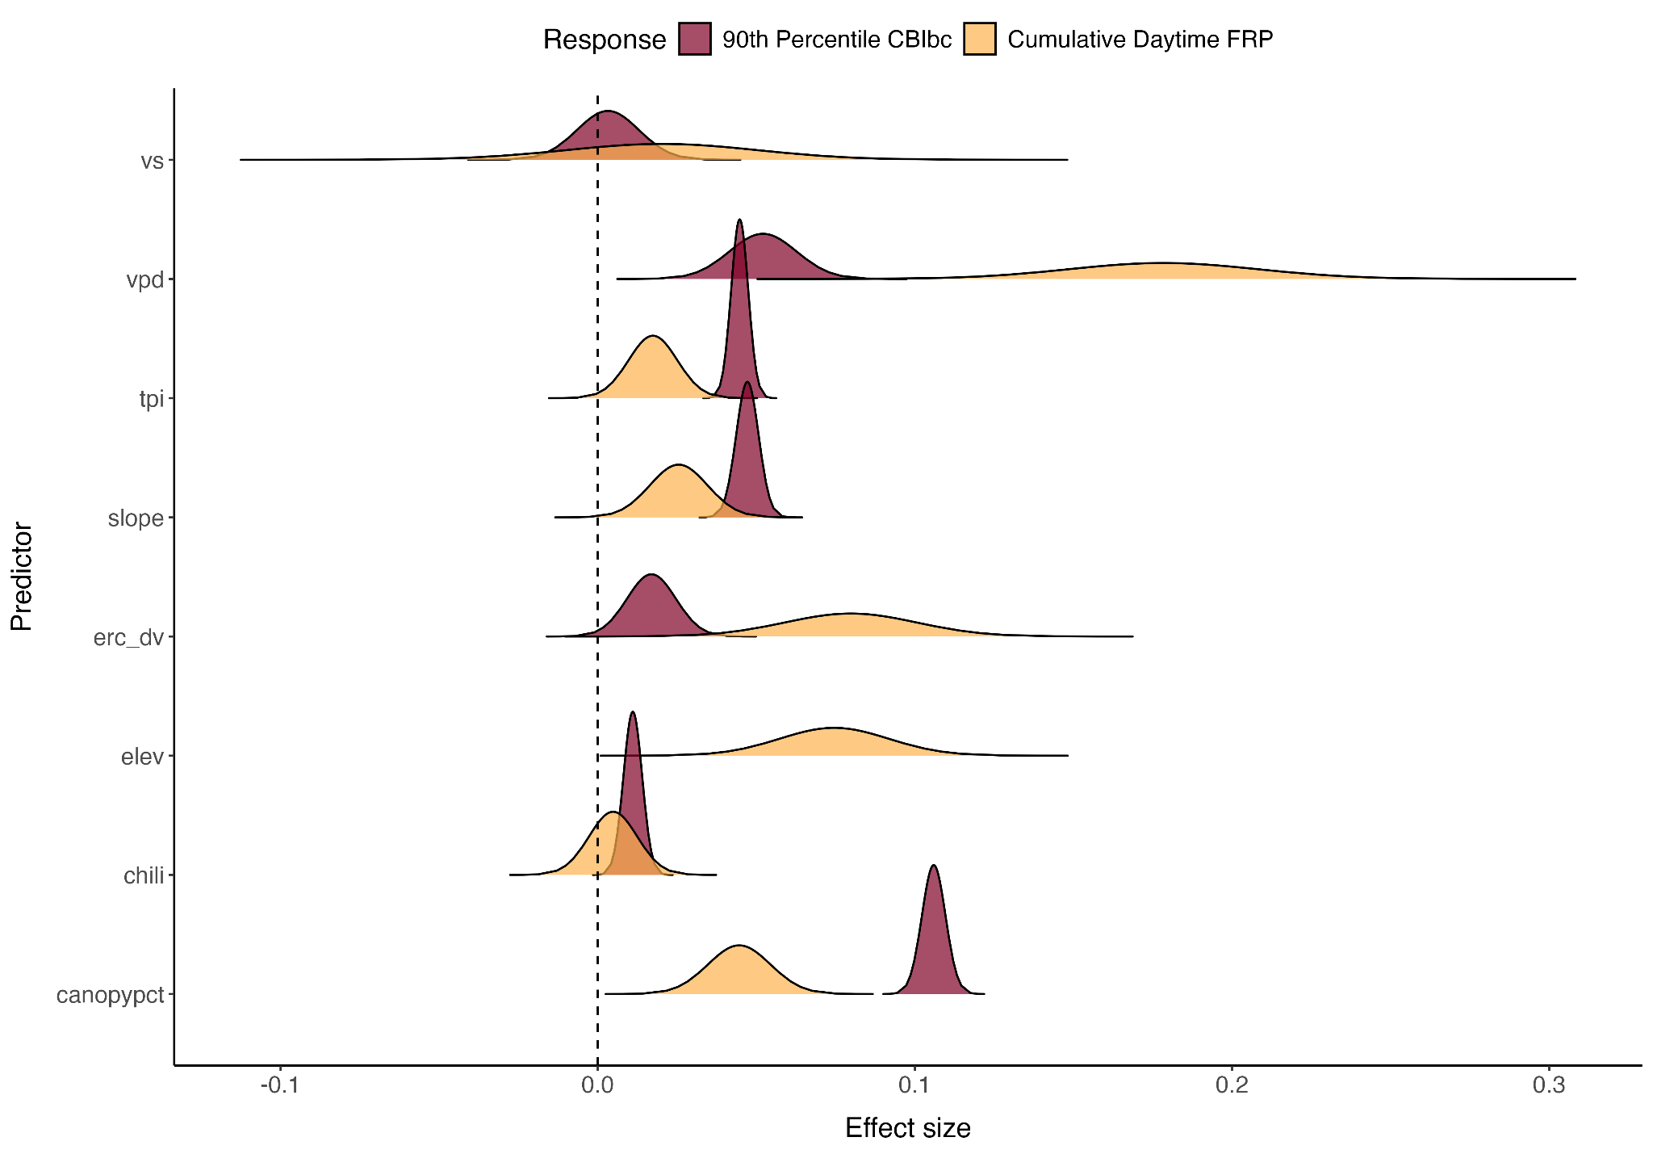

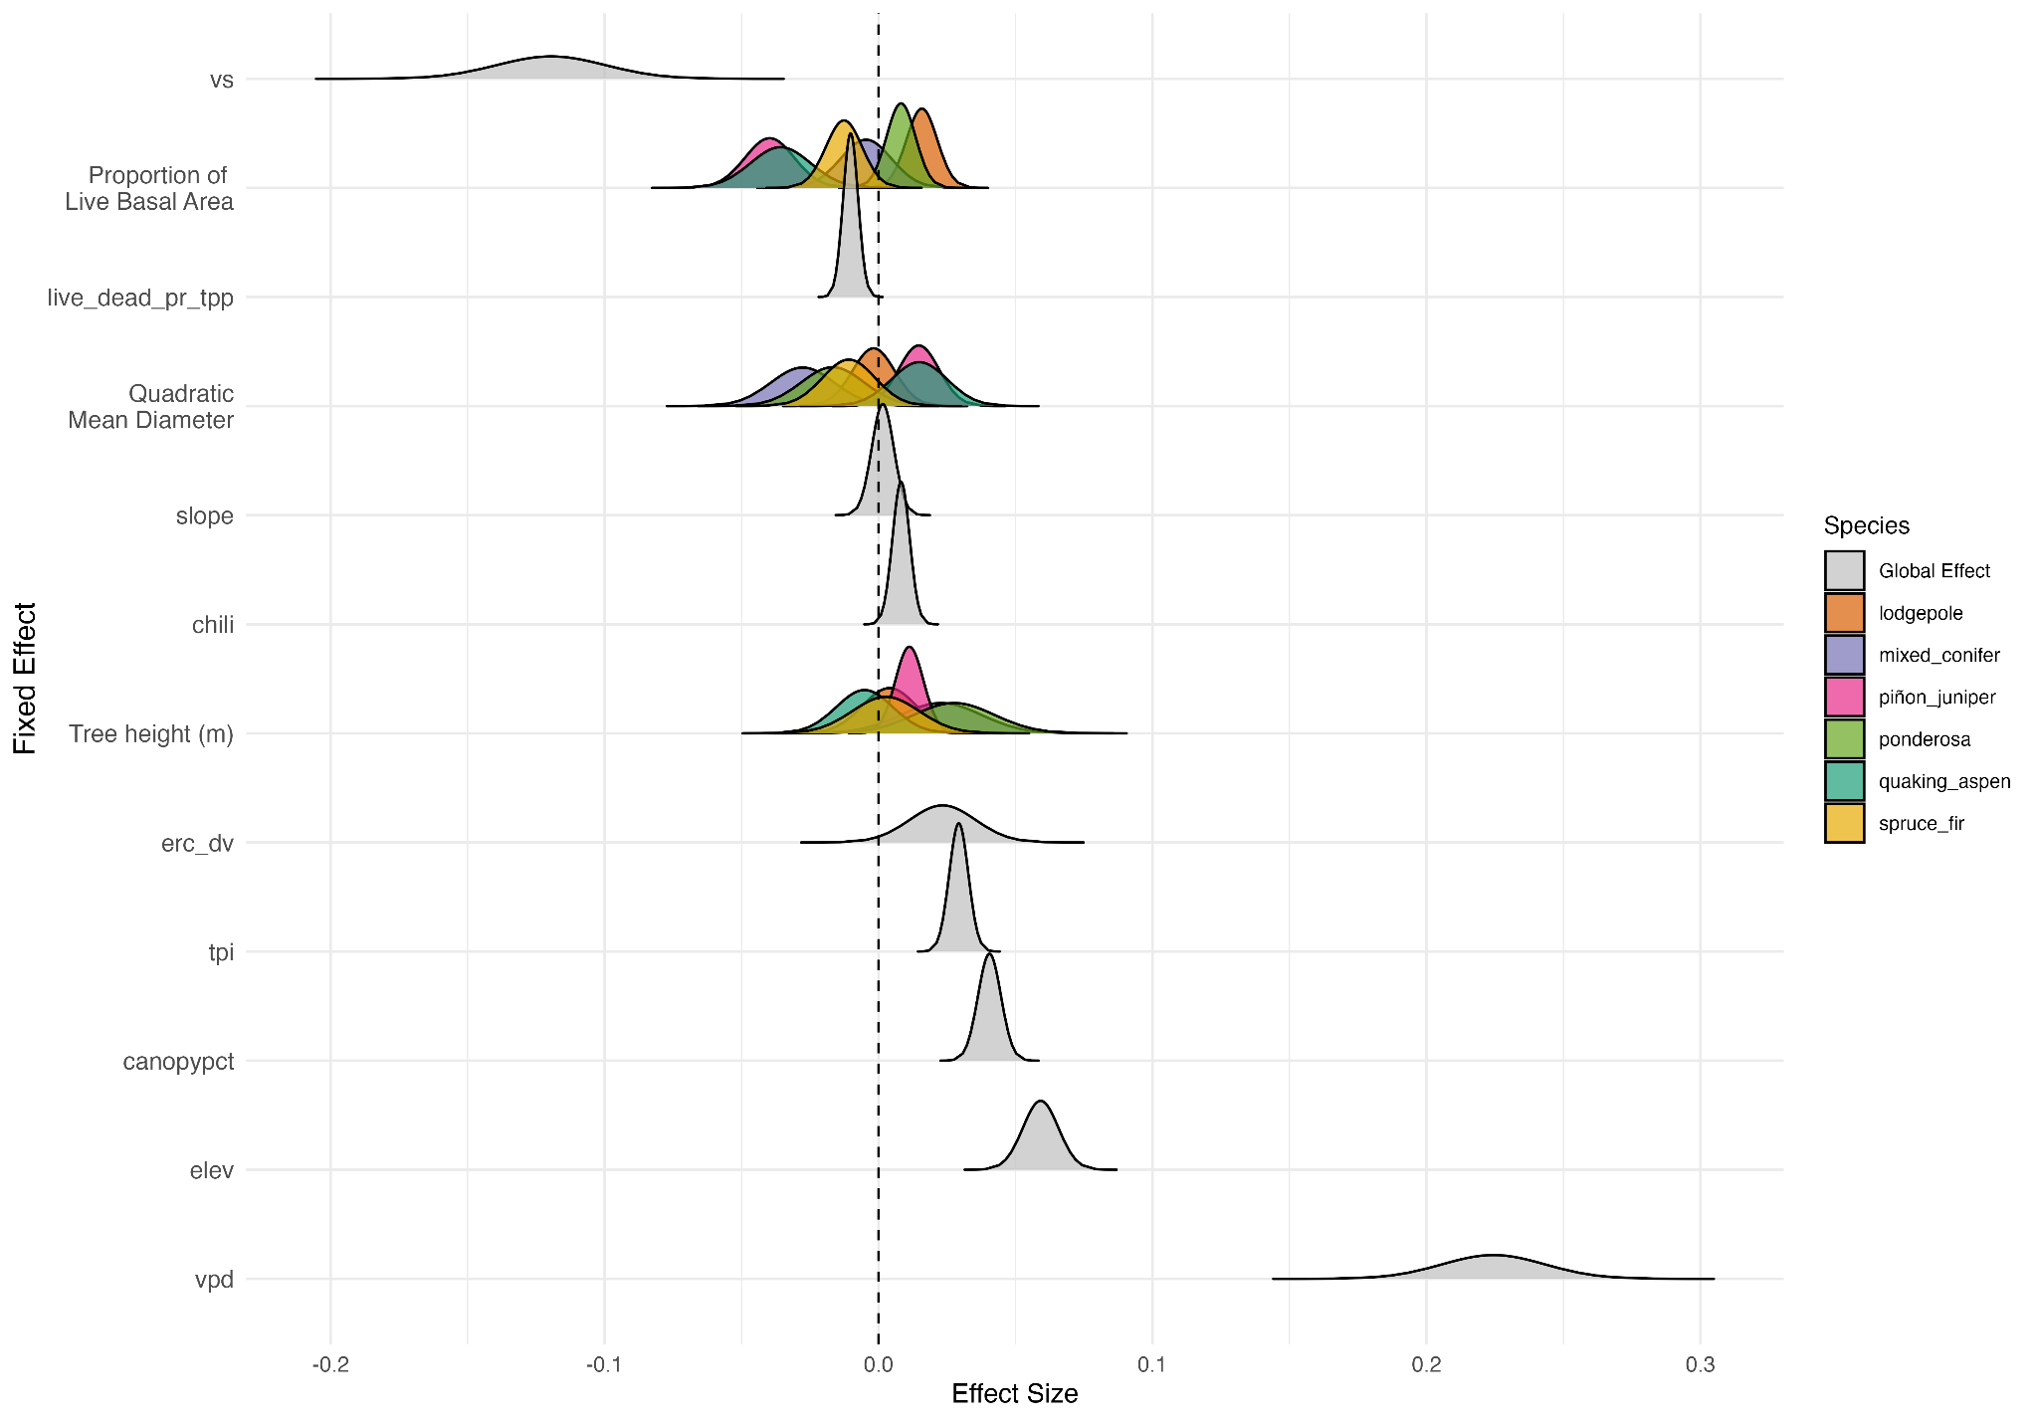

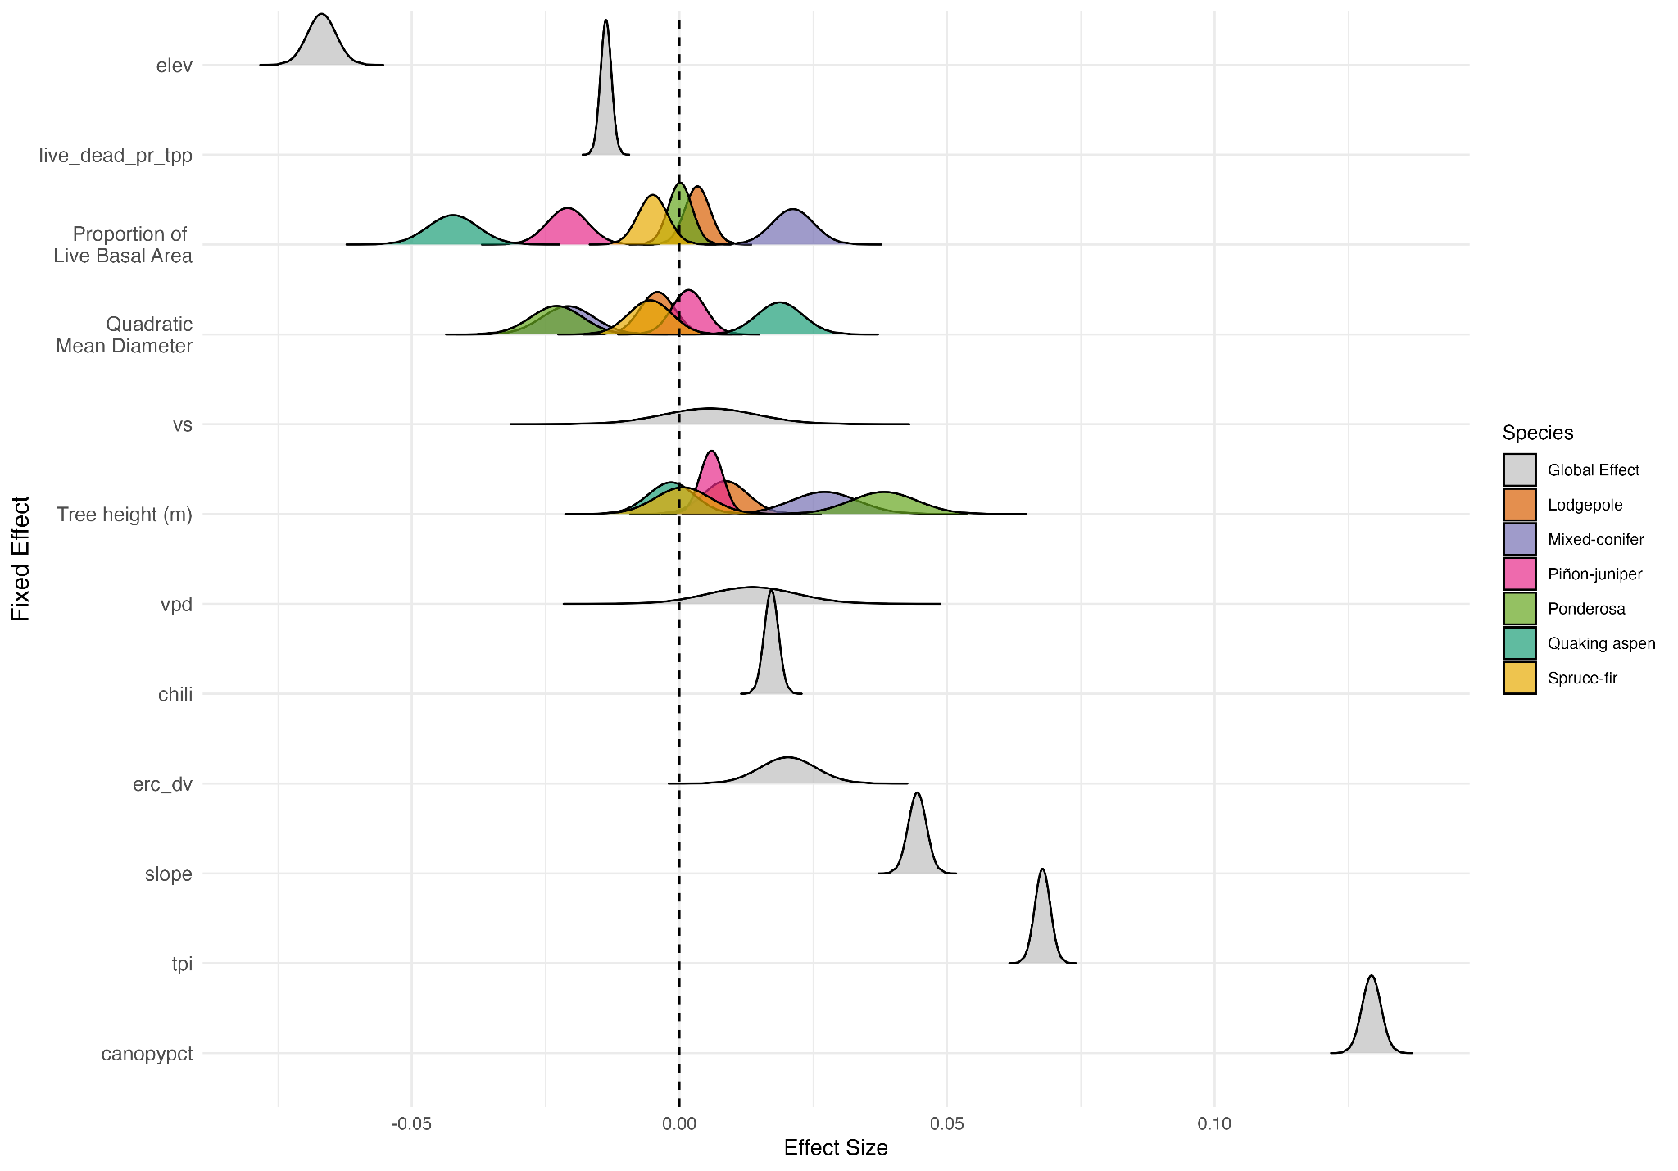

**MODEL RESULTS TABLES?**

**CUTS**

Aspen also responds readily to canopy opening disturbances such as wildfire or coppice silviculture, providing critical forest resilience especially in regions where conifer regeneration is lacking due to compound disturbances (Andrus et al., 2021; W. D. Shepperd et al., 2015).

Simulated fire behavior in aspen stands of northern Utah showed that greater aspen dominance reduced crown-fire potential, particularly under moderate fire weather conditions (DeRose & Leffler, 2014). Similarly, an experimental study in the boreal forests of Canada showed that high-intensity crown fire in conifer-dominated stands failed to sustain itself in adjacent aspen-dominated stands (Alexander, 2010).

The expansion of deciduous forest species, which are associated with less flammable fuel profiles, has been proposed as one unique solution for reducing wildfire hazard without completely removing fuels (Fechner & Barrows, 1976; Girardin & Terrier, 2015; Nesbit et al., 2023). In particular, quaking aspen (*Populus tremuloides Michx.*), which is the most widely distributed tree species in North America (Rogers et al., 2020), has been characterized by potentially fire-moderating traits such as lower canopy bulk density, higher canopy base height, and greater leaf moisture content (DeByle & Winokur, 1985; W. Shepperd, 1990; Shinneman et al., 2013). Simulated potential fire behavior in aspen stands of northern Utah showed that greater aspen dominance reduced crown-fire potential, particularly under moderate fire weather conditions (DeRose & Leffler, 2014). Similarly, an experimental study in the boreal forests of Canada showed that high-intensity crown fire in conifer-dominated stands failed to sustain itself in adjacent aspen-dominated stands (Alexander, 2010). In addition, responding to canopy-opening events like wildfire, aspen are often the first to colonize disturbed areas, providing crucial forest resilience in post-fire landscapes (Bartos, 2001; Landhäusser et al., 2010; W. D. Shepperd et al., 2015). Aspen, with these fire-moderating traits, may offer a natural buffer to extreme fire behavior and post-fire ecosystem impacts. However, there remains a knowledge gap between desired management outcomes and scientific understanding of how, when, and where aspen forests moderate fire behavior, especially relative to forest composition and structure characteristics at regional-to-continental scales (Nesbit et al., 2023). Still fewer studies have been conducted in the Southern Rockies, where quaking aspen is overwhelmingly the dominant deciduous forest type.

In the Southern Rockies, forest types generally follow distinct fire regime characteristics that are tied to climate, dominant species, elevation, and fuel condition, and are often defined based on the frequency, intensity, and severity characteristics (Schoennagel et al., 2004; Tepley et al., 2018). For example, low elevation pPonderosa pine forests in the Southern Rockies are often defined as having historically high frequency, low intensity/severity fire behavior (*ref*), although this dynamic has been altered by a century of fire suppression, changing fire weather conditions, and increased development of the Wildland Urban Interface (WUI) (*refs*). Conversely, high-elevation lodgepole pine and or subalpine spruce-fir forests are typified by low frequency, high intensity/severity wildfire, often as stand-replacing events (Sibold et al., 2006). In the case of aspen, which co-exists with nearly all major forest types of the Southern Rockies across elevation ranges and site conditions (Bartos, 2001; Kulakowski et al., 2013; Landhäusser et al., 2010), fire activity is driven by functional type (*i.e.*, seral or stable), stand structure, and tree age (Morris et al., 2019; Shinneman et al., 2013). Where aspen persists in seral types, or having a conifer component, fire activity (*i.e.*, frequency, behavior) is generally higher than in stable or pure stands (Shinneman et al., 2013). While aspen are generally considered “fire-resistantresilient” because of their moderating effects on fire behavior and prolific response in post-fire landscapes (*ref*), they *will burn* under the right conditions (Alexander, 2010; DeRose & Leffler, 2014). The composition and structure of aspen stands and the conditions (e.g., fire weather, fuel moisture, topography) under which fires are burning likely have a profound effect on observed fire behavior, especially relative to co-occurring major forest types in the Southern Rockies. However, studies elucidating these relationships on observed fire behavior are severely limited, in part due to the lack of during-fire measurements of fire behavior. The widespread availability of remote sensing data before, during, and after a wildfire event presents an opportunity to address this need by relating satellite-derived metrics of fire intensity and severity to forest characteristics, fire weather, and landscape conditions.

Satellite remote sensing has been widely applied to study fire regime characteristics, active fire behavior, and post-fire impacts (Szpakowski & Jensen, 2019). Active fire detection has become a crucial tool for fire managers and researchers to detect, monitor, and assess global fire activity (Wooster et al., 2021). Aggregation of active fire pixels has been used to delineate fire events and recreate daily fire progression maps, providing crucial data to understand the drivers of fire growth patterns and changes in fire regimes (Balch et al., 2020b, 2024; Coop et al., 2022; Parks, 2014; Scholten et al., 2024). Where moderate resolution optical imagery is considered, spectral channels in the mid-infrared (MIR; 4 µm) are sensitive to actively burning fires, capturing a majority of the radiometric energy released by both cool/smoldering (450-850 K) and hot/active (800-1200 K) fires (*ref*). Measurements in this spectral range are also highly correlated with the rate of biomass consumption per unit time (Kaufman et al., 1998; Wooster et al., 2003). Middle infrared radiance is thus employed to calculate the fire radiative power (FRP), a measure of energy released, often in megawatts (MW), by actively burning fires. Studies have applied satellite-derived FRP to, for example, track wildfire smoke emissions (Li et al., 2019) and investigate the relationship between energy released and fire size (Laurent et al., 2019). Other studies have used FRP to measure relationships between biomass consumption rates and fuel moisture content (Smith et al., 2013), canopy interception of out-going radiation (Roberts et al., 2018), and land cover type (K. Barrett & Kasischke, 2013; Fu et al., 2020). Despite this growing body of work, satellite-derived FRP has thus far been understudied as it relates to forest composition, fire weather, and landscape factors, especially in the Southern Rockies.

While studies relating vegetation type to fire intensity may be limited, remote sensing has been widely applied for decades to map and characterize burn severity in post-fire assessments. Severity is a measure of ecosystem impacts and is often characterized by the loss of organic matter on the landscape (Keeley, 2009). Measurements of fire severity from satellite remote sensing have been applied widely to understand fire effects to ecosystems (*ref*), effectiveness of fuels treatments (*ref*), and post-fire vegetation trajectories (*ref*). Satellite-derived fire severity metrics such as the difference normalized burn ratio (dNBR) use the spectral differences between pre- and post-fire multispectral imagery and have been shown to correlate strongly with field-based measurements (Roy et al., 2006). However, these metrics often use non-standardized units and can be difficult to interpret across different biomes and vegetation types (Morgan et al., 2014; Parks et al., 2019a). New satellite-derived severity metrics, such as the composite burn index (CBI), has recently been developed to link field-based measurements of CBI to Landsat imagery (Parks et al., 2019b). The CBI provides an ecologically-relevant and standardized measurement of fire severity which can improve comparisons made between fire events of different biomes. Thus far, studies quantifying the relationship between satellite retrievals of FRP and subsequent burn severity are lacking, though field based measurements suggest there should be a strong relationship (*ref*).

Middle infrared spectral channels are sensitive to actively burning fires and highly correlated with the rate of biomass consumption per unit time (Kaufman et al., 1998; Wooster et al., 2003). Middle infrared radiance is thus employed to calculate the fire radiative power (FRP), a measure of energy released, often in megawatts (MW), by actively burning fires. Studies have applied satellite-derived FRP to, for example, track wildfire smoke emissions (Li et al., 2019) and investigate the relationship between energy released and fire size (Laurent et al., 2019). Other studies have used FRP to measure relationships between biomass consumption rates and fuel moisture content (Smith et al., 2013), canopy interception of out-going radiation (Roberts et al., 2018), and land cover type (K. Barrett & Kasischke, 2013; Fu et al., 2020). Despite this growing body of work, satellite-derived FRP has thus far been understudied as it relates to forest composition, fire weather, and landscape factors, especially in the Southern Rockies.

Satellite RS has been extensively applied to study fire regimes, active fire behavior and post-fire impacts (Szpakowski & Jensen, 2019).

In the western U.S., fire regimes are changing in response to increasing human ignitions (*ref*), a more fire-conducive climate (*ref*), and over a century of fire exclusion in fire-adapted landscapes (*ref*). These changes have altered fire behavior (*ref*), forest composition (*ref*) and in some cases have ushered ecosystem transformations such as the conversion of forest to non-forest following high severity wildfire (*ref*). In response, varied adaptive management strategies for reducing wildfire hazard and improving forest resilience are urgently needed [(Hessburg et al., 2021)](https://www.zotero.org/google-docs/?broken=lGNp8A). The direct modification of forest composition and structure is a viable management tool often leveraged to reduce wildfire risk to communities and ecosystems [(Prichard et al., 2021; Ziegler et al., 2017)](https://www.zotero.org/google-docs/?broken=qYM0r1). These management actions often involve the reduction of fuels through mechanical treatment or prescribed fire, thereby reducing extreme fire intensity and severity potential [(Agee & Skinner, 2005; Stephens et al., 2009)](https://www.zotero.org/google-docs/?broken=6XHu6r). However, the reduction of fuels may in some cases be

Composition and structure (e.g., size, biomass, canopy cover, etc.) together influence *fire intensity*, or how hot a fire burns, and *fire severity*, or the consumption of organic matter (Hagmann et al., 2021; Keeley, 2009; Meigs & Krawchuk, 2018). Fire intensity and severity, in turn, influence suppression difficulty, during and post-fire impacts to the built environment (e.g., structure loss, water quality, and air quality)during and post-fire community impacts, and ecosystem functioning (Keeley, 2009; Plucinski, 2019). Thus, the direct modification of forest composition and structure is a viable management tool often leveraged to reduce wildfire risk to communities and ecosystems (Prichard et al., 2021; Ziegler et al., 2017). These management actions often involve the reduction of fuels through mechanical treatment or prescribed fire, thereby reducing extreme fire behavior potential (Agee & Skinner, 2005; Stephens et al., 2009). However, as fire activity and impacts continue to rise in the western U.S. (Abatzoglou et al., 2021; Schoennagel et al., 2017), varied adaptive management strategies for reducing hazard and improving forest resilience to wildfire are urgently needed (Hessburg et al., 2021).

In the western U.S., fire regimes are changing in response to increasing human ignitions (*ref*), a more fire-conducive climate (*ref*), and over a century of fire exclusion in fire-adapted landscapes (*ref*). These changes have increased the wildfire hazard (*ref*), altered fire behavior (*ref*), forest composition and structure (*ref*) and in some cases have ushered ecosystem transformations such as the conversion of forest to non-forest following high severity wildfire (*ref*).

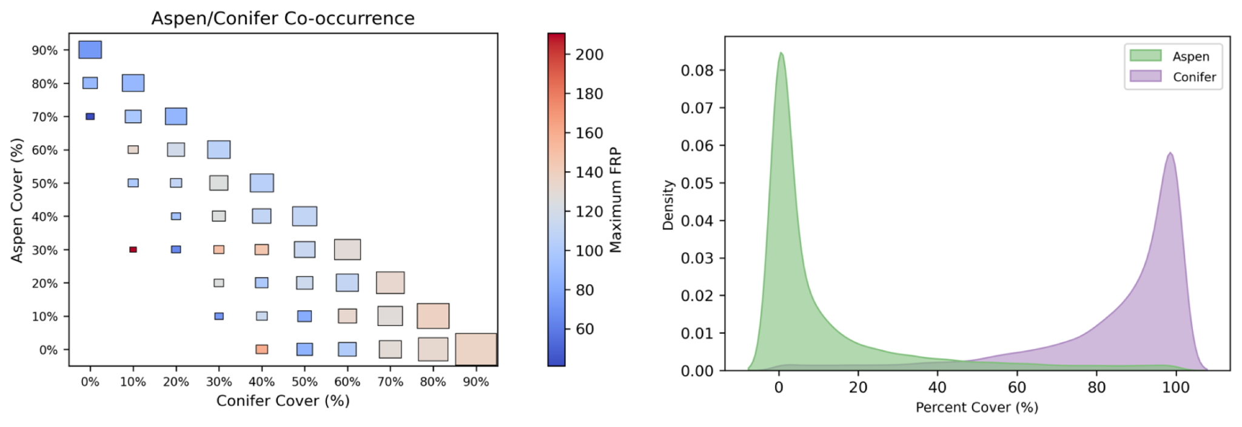

**Figure S3.** (A)Maximum FRP summarized across varying levels of aspen/conifer co-occurrence. Conifer here groups all other evergreen forest types in one category. (B) Distribution of percent cover overlap between aspen and conifer.

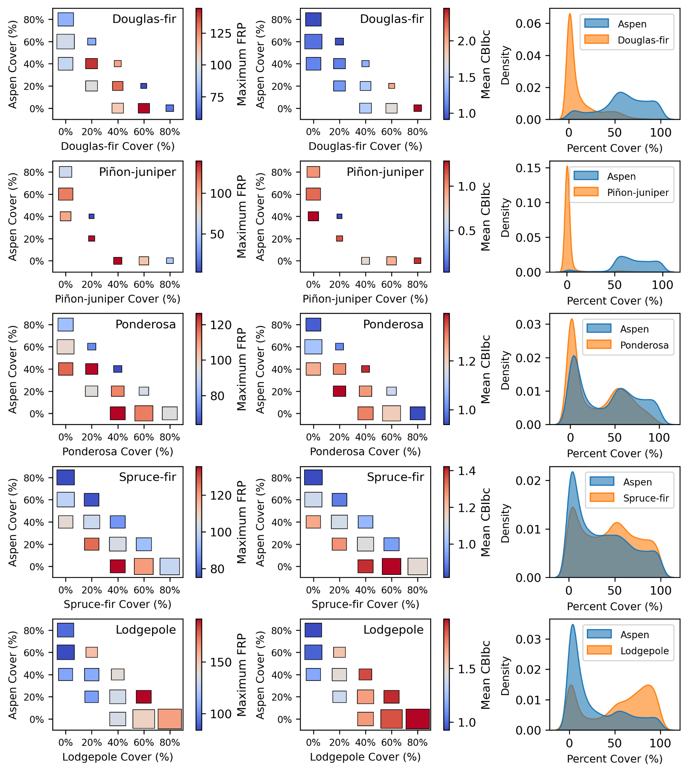

**Figure 5.** Effects of species co-occurrence on maximum FRP. Column (A) two-way interactions between aspen and co-occurring conifer percent cover where the aspen + co-occurring cover is >50%. Column (B) distribution of aspen and co-occurring species percent cover, again where at least 50% of forested area is made up of those two types.